**SUSTAINABLE OUTREACH AND UNIVERSAL LEADERSHIP LIMITED   
(SOUL)**



**PROJECT EDULEAD**



**POLYTECHNIC USER MANUAL**

**VERSION HISTORY**

| **Date** | **Version No.** | **Created By** | **Updated Section** | **Updated By** |
| --- | --- | --- | --- | --- |
| 08-09-2022 | Version 0.1 | Nehal Kumar |  |  |
|  |  | Rupali Bhatta |  |  |

**Introduction**

The user manual is designed to provide relevant, and content specific information for the user to use the SLCM and Accounts functionality of the Polytechnic Module in the Edulead product.

Purpose and Scope

The purpose of the document is to provide step-by-step guidance to users for Accounts and SLCM function work.

Edulead Users

The system shall be available to and accessible by Education Administrator, Accounts Officer, Accounts User, Instructor and Student of the organization

**Login**

Edulead Users will navigate to the URL and enter their credential in the screen as shown below

URL - https://testkp.eduleadonline.com/#login

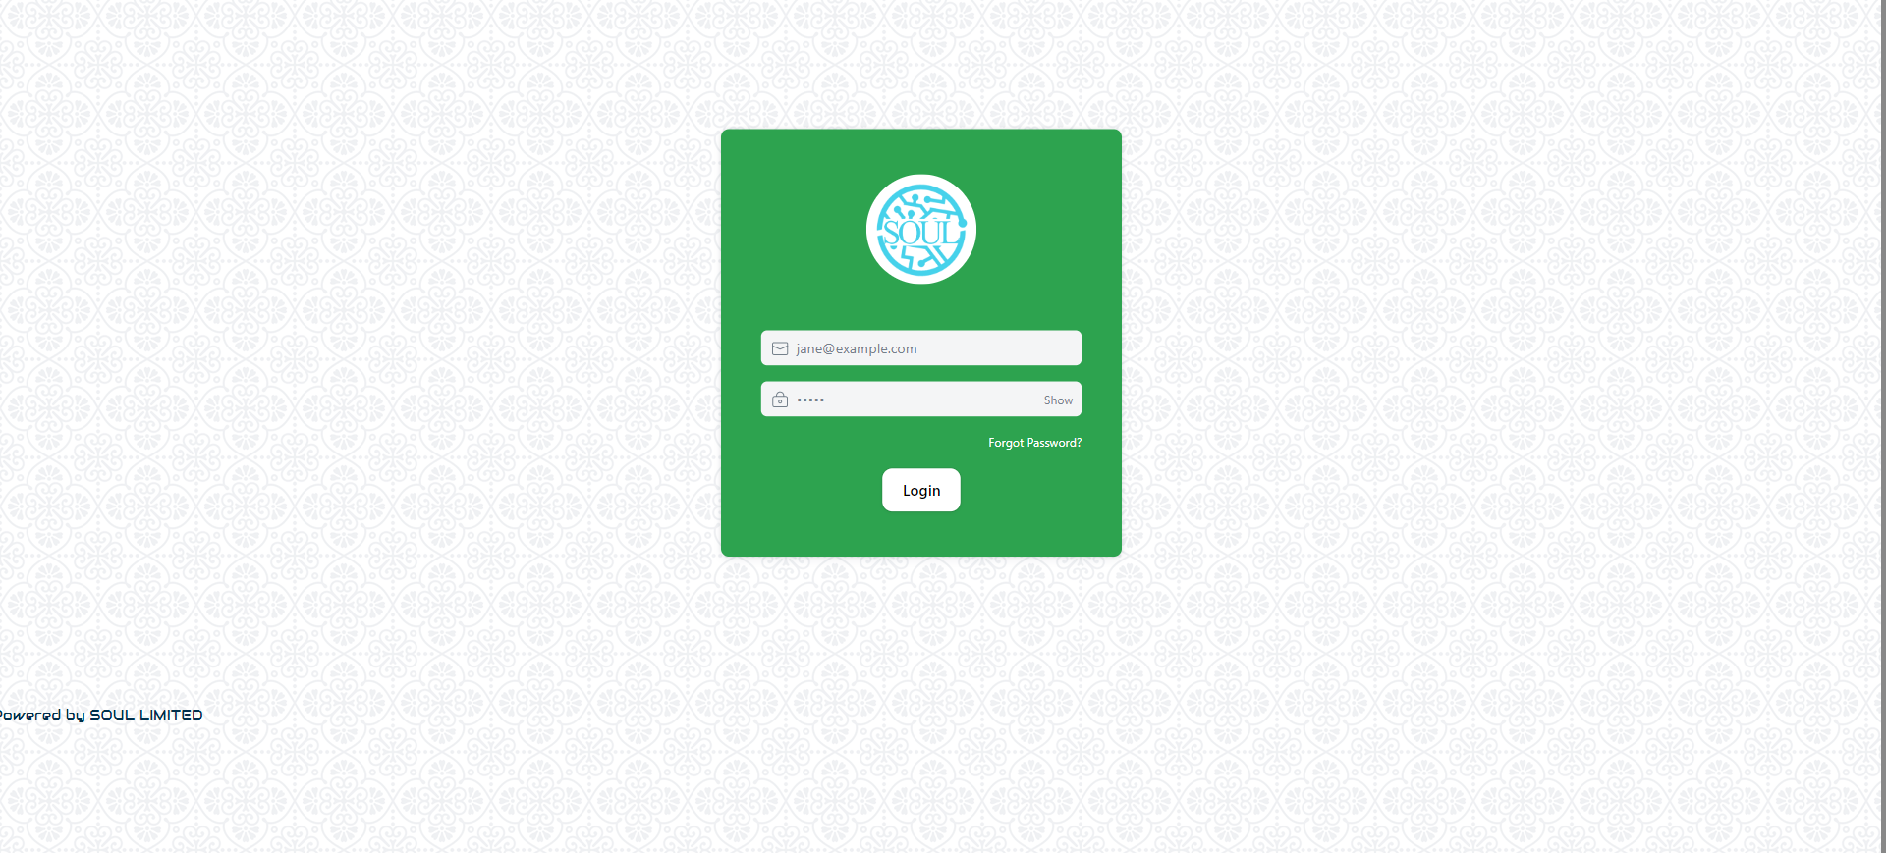

**Login with Email-ID**

Edulead Users can login to the screen with their Email-ID and their password.

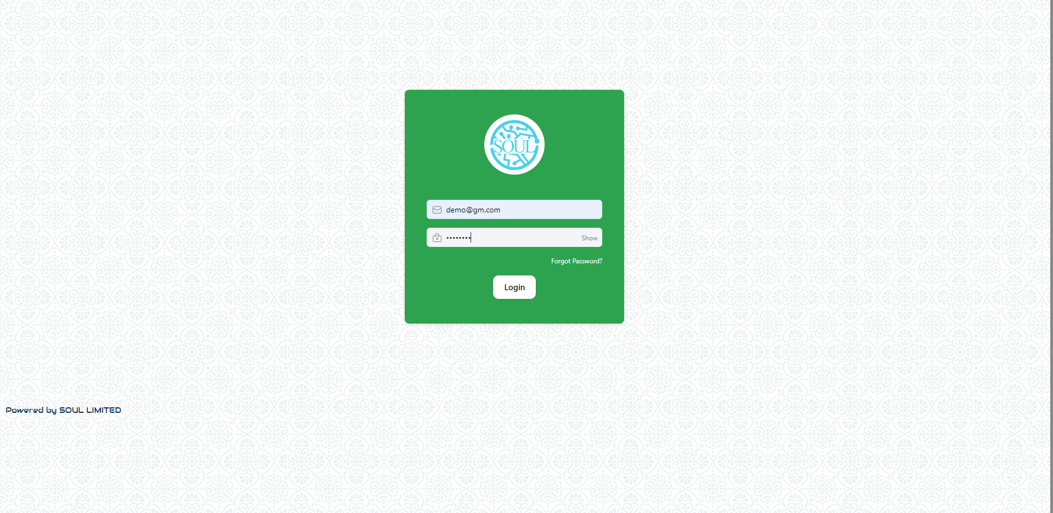

**Masters Modules**

**Department**

A Department is a specialized functional area or a division within an organization.

To access Department, go to:

Home > Polytechnic> Masters > Department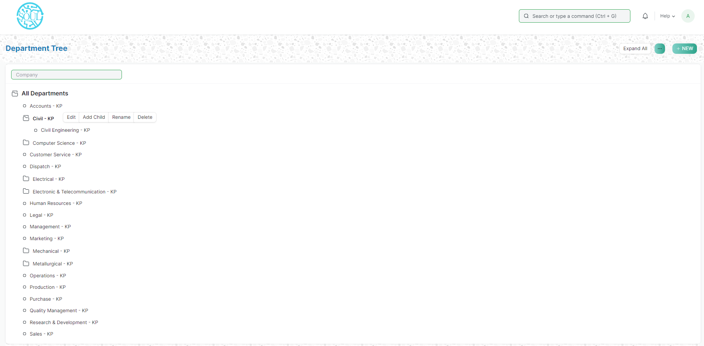

Department is a tree-structured master, which means you can create parent departments and sub-departments as shown below:

Prerequisites

Before creating a Department, it is advisable you create the following documents:

* Company

How to create a Department?

1. Go to the Department list, click on New.
2. Enter Department name.
3. Select Company name.
4. Select “Is Group” and “Is Stream” if there are any child departments under the parent department.
5. Save.

**Program Grade**

A Program Grade is a specialized functional area or a division within the Department.

You can add Program Grade, modify and Programs can be linked to it.

To access Program Grade, go to:

Home > Polytechnic > Masters > Program Grade

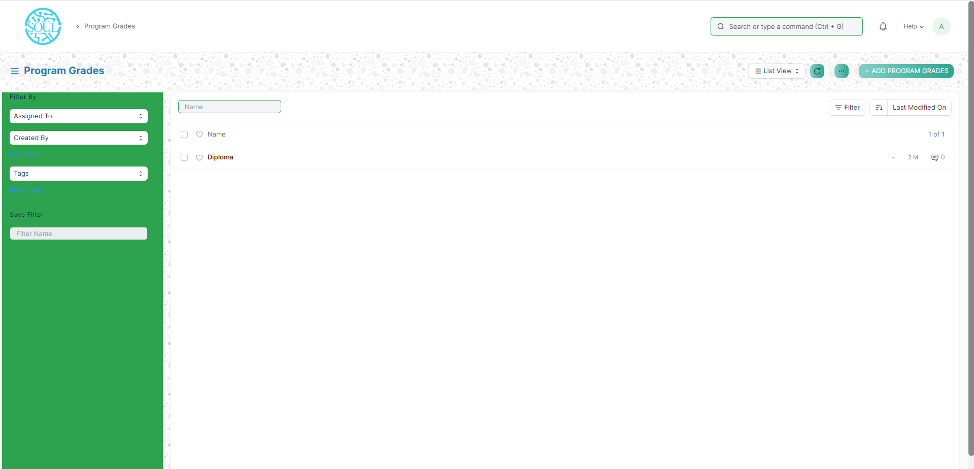

How to create a Program Grade?

1. Go to the Program Grade list, click on Add Program Grade.
2. Enter Program Grade Name
3. Save.

Program

A Program will have an educational curriculum defined by your institute to streamline the learning process and goals in each subject or course.

To access the Program list, go to:

Home > Polytechnic > Masters > Program

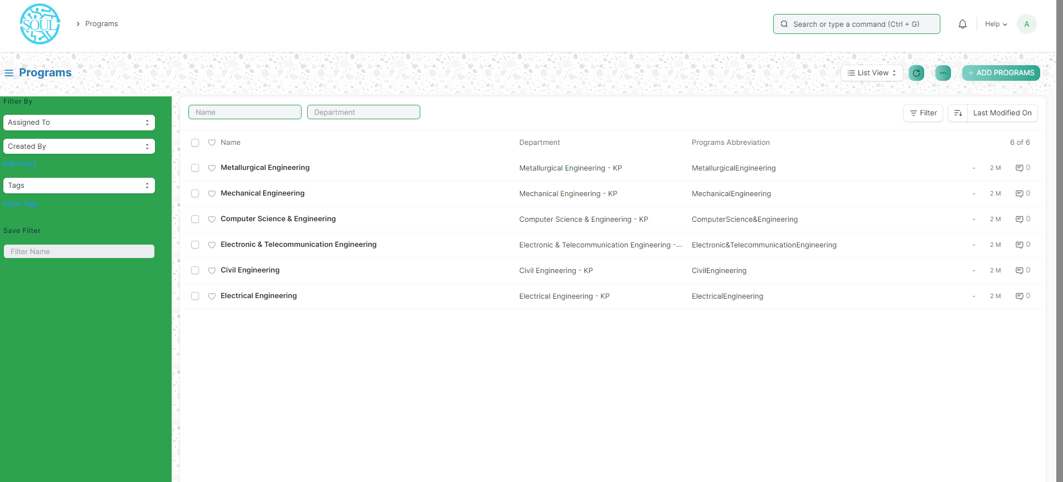

Prerequisites

To create a New Program, it is advised to create the following first:

1. Department
2. Course

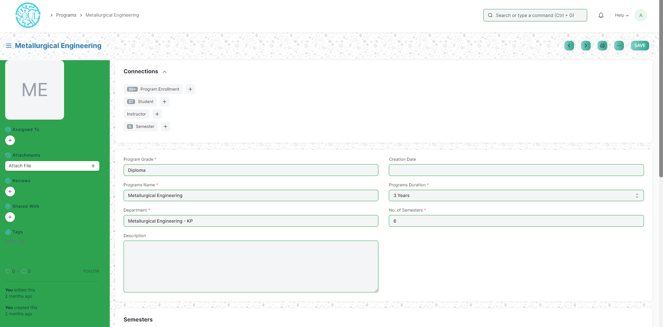

How to create a new Program?

1. Go to the Program list and click on New.
2. Enter the Program Name and the Program Abbreviation.
3. Select the Department for the Program.
4. Select and add the courses within the Program.
5. Add the description of the Program which you want to be visible on the portal
6. Save.

Semesters

A semester is an individual part of a program. A semester system divides the academic year into different sessions which have various course enrollments enlisted in them.

To go to Semesters, go to:

Home > Polytechnic > Masters > Semesters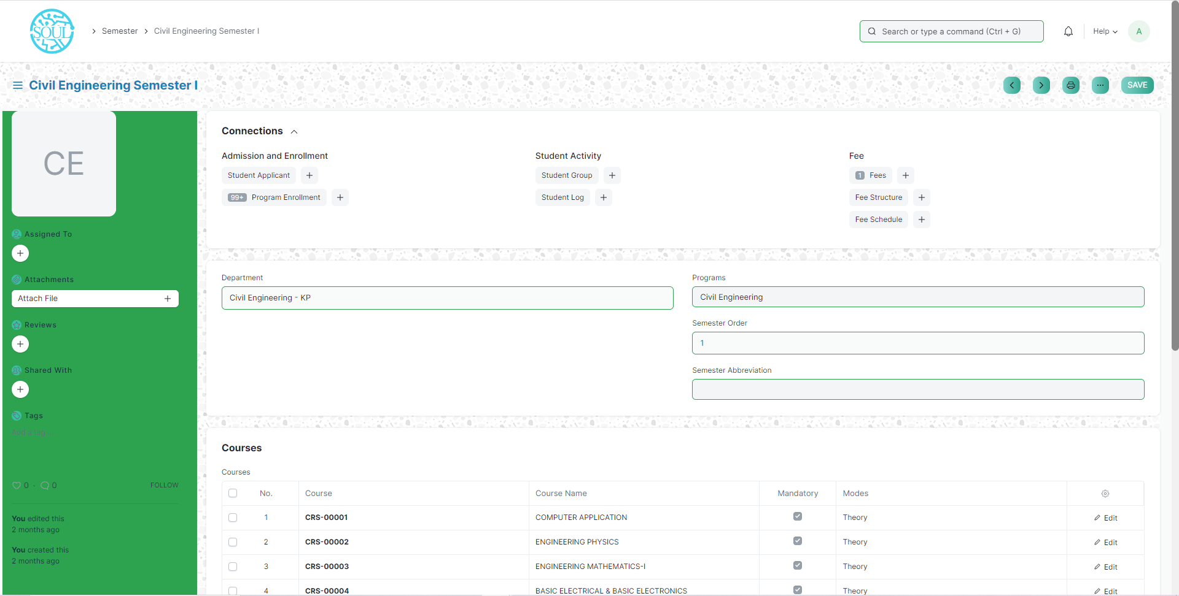

Prerequisites

To create a New Semester, it is advised to create the following first:

* + - 1. Program

How to create a new Semester?

1. Method 1:
   1. Upon saving the Program we can add Semesters in the Semesters table and save the Program.
   2. The semesters get automatically saved and linked with the respective programs.
2. Method 2:
   1. Go to the Semester list and click on add Semester.
   2. Select and enter the Semester Name.
   3. Select and enter the Program.
   4. Select and enter the Semester Abbreviation.
   5. Select and add courses if required.
   6. Save.

**Courses**

A course can be considered as a subject or a part of an educational program which is to be taught for a term.

To access the course list, go to:

Home > Polytechnic > Masters > Course

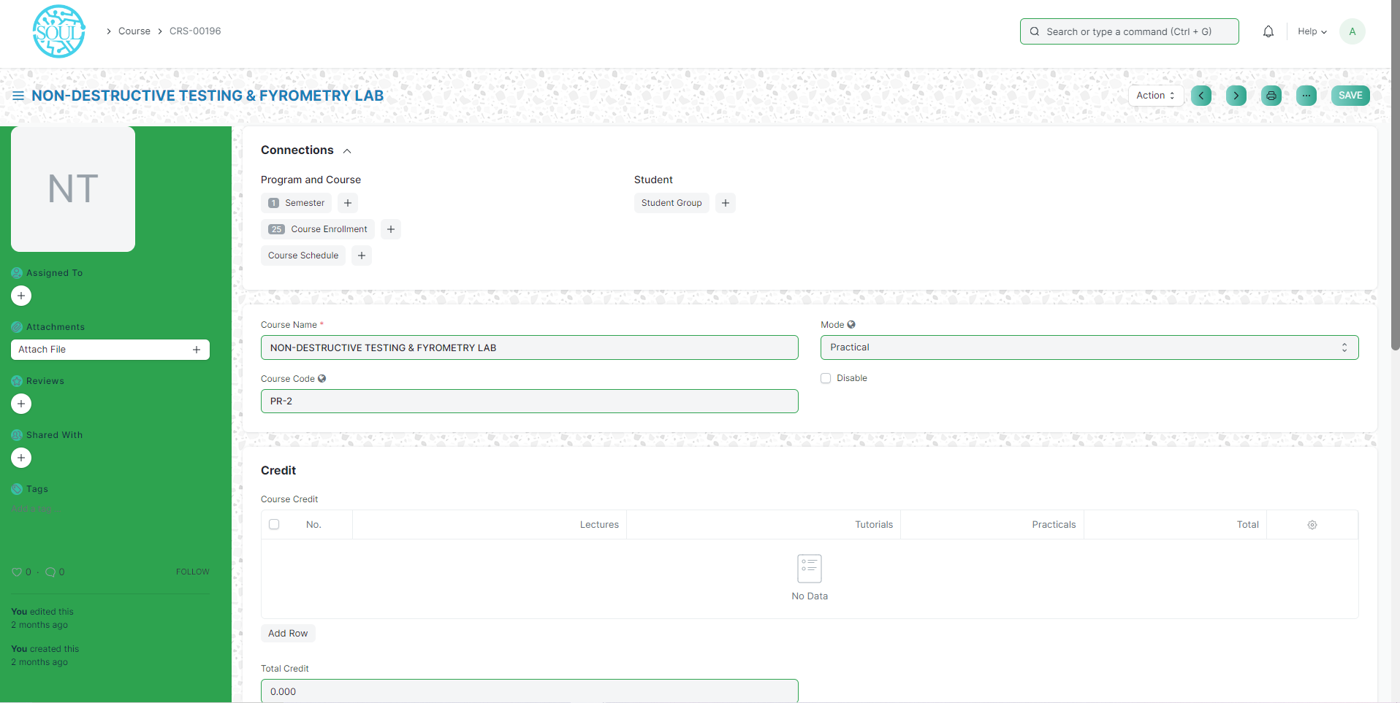

Prerequisites

Before creating a course, it is advised to create:

1. Department
2. Topics

How to create a course?

1. Go to the Course List and click on New.
2. Enter the Course Name.
3. Select the Department under which this course is being made.
4. Add the Topics. You can also create the topics from here itself.
5. Add the Description for the course.
6. Save.

Classroom

Classroom refers to a tutoring space which can be set as the venue for courses or examinations.

To access Room, go to:

Home > Polytechnic > Masters > Classroom

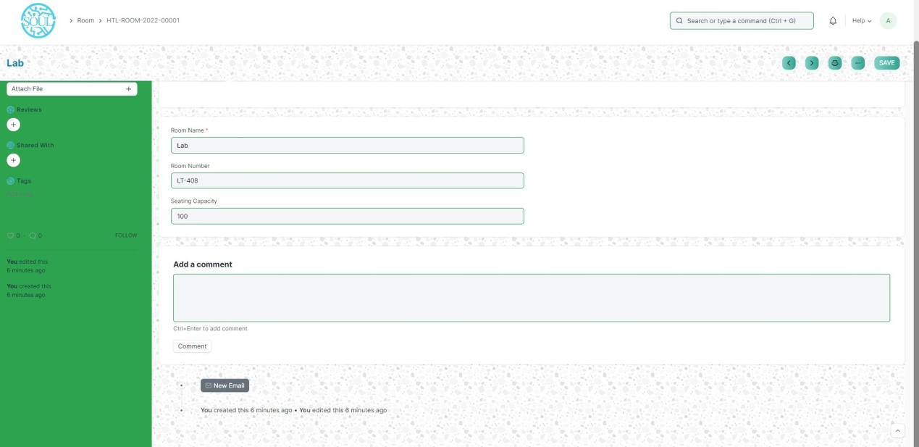

How to create a Room?

1. Go to the Room list and click on New.
2. Add the name of the room.
3. Add the Room Number for the selected room.
4. Enter the Seating capacity for the room.

Academic Year

An academic year is a period which the Educational Institutes, Schools and Universities use to measure a quantity of study.

To go to Academic Year, go to:

Home > Polytechnic > Masters > Academic Year

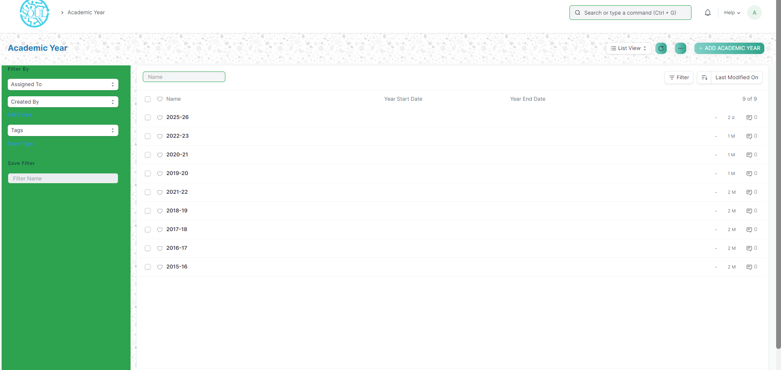

How to create an Academic Year?

1. Go to the Academic year list and click on New.
2. Add the new Academic year.
3. Add the Year Start date and Year End date.
4. Save

Academic Term

An Academic Term would become a part of the Academic Year, during which the Institute will assess its students on the curriculum defined for that term. It could be a Quarter, Trimester or a Semester.

To access Academic term, go to:

Home > Polytechnic > Masters > Academic Term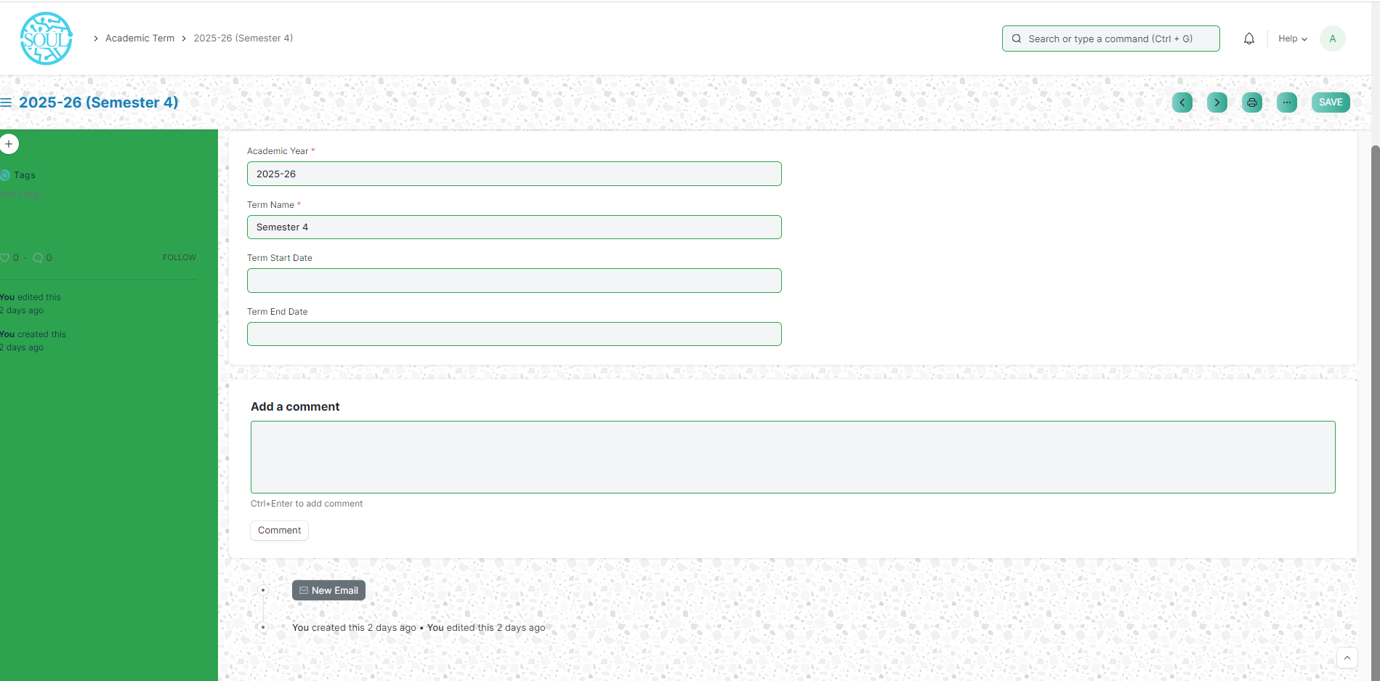

How to create an Academic Term?

1. Go to the Academic term list and click on New.
2. Select the new Academic year.
3. Add the Term name, Term Start date and Term End date.
4. Save

**Student Details Module**

**Student**

The Student document will hold all the data of any Student in your Academy like their Personal Information, Photo, Date of Birth, Address, etc.

To access Student, go to:

Home> Polytechnic > Student Details > Student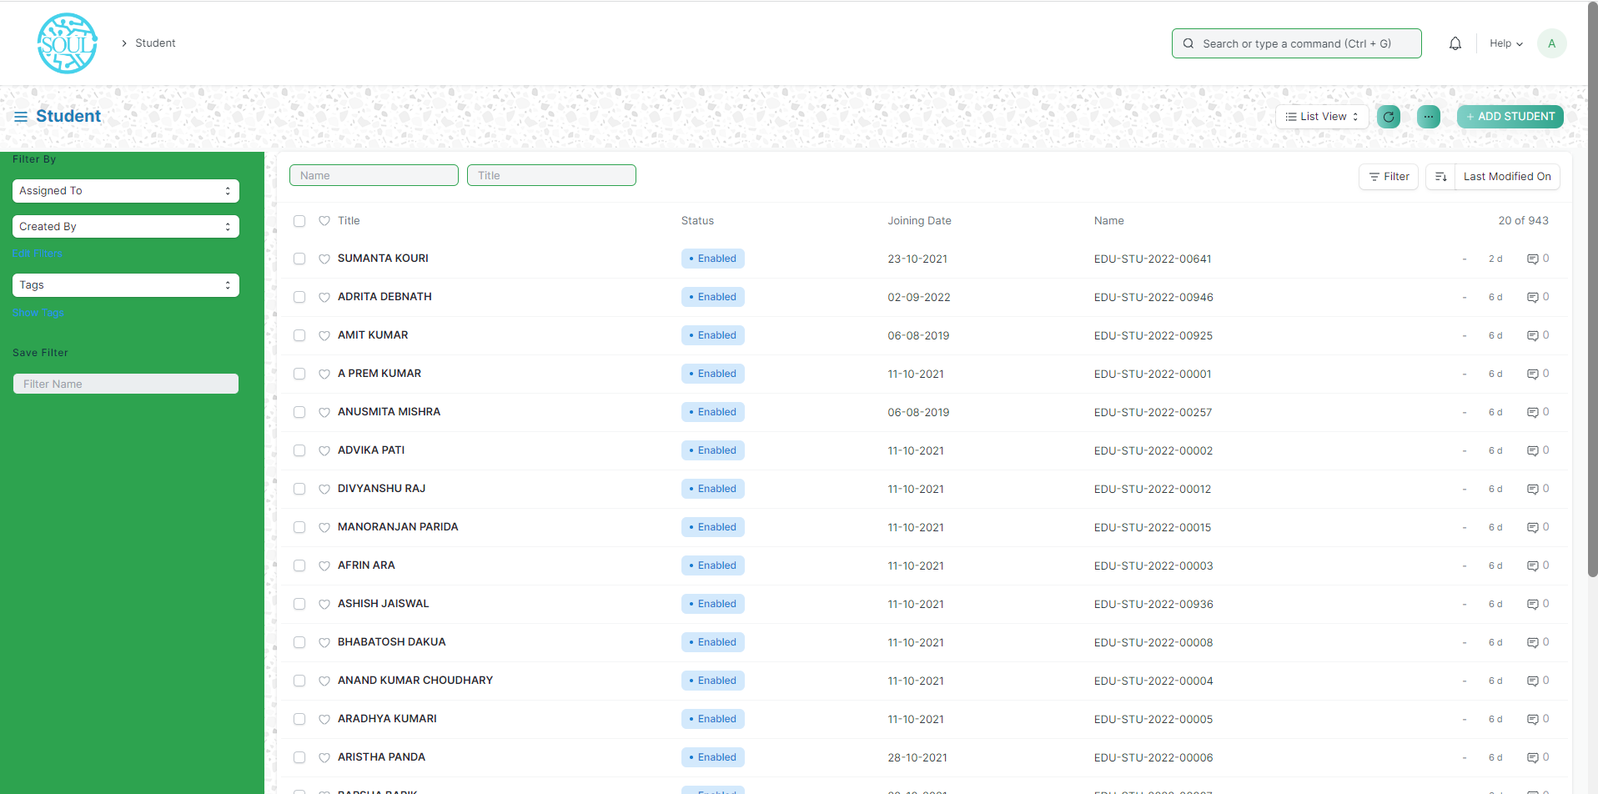

How to create a New Student?

1. Go to the student list and click on New.
2. Enter the First Name, Middle Name and Last Name of the student.
3. Enter other details like Student Email Address, User ID (If Applicable), Joining Date etc.
4. Save.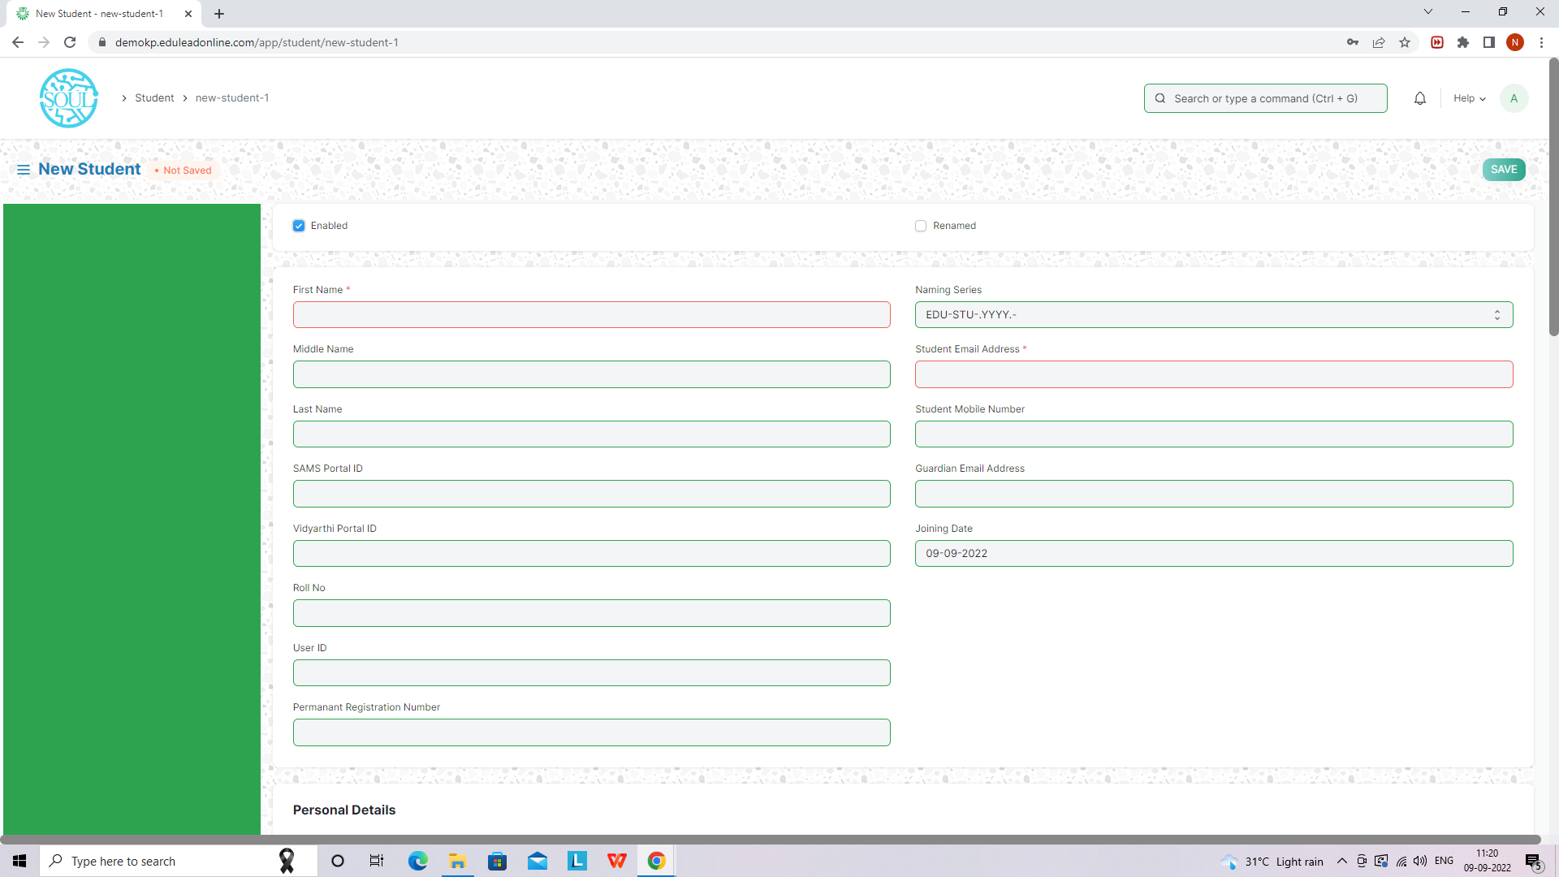

**Student Category**

Student Category allows you to classify the students based on various categories.

When a Student is enrolled for a Program, you can select the Category for the Student.

To access Student category, go to:

Home> Polytechnic > Student Details > Student Category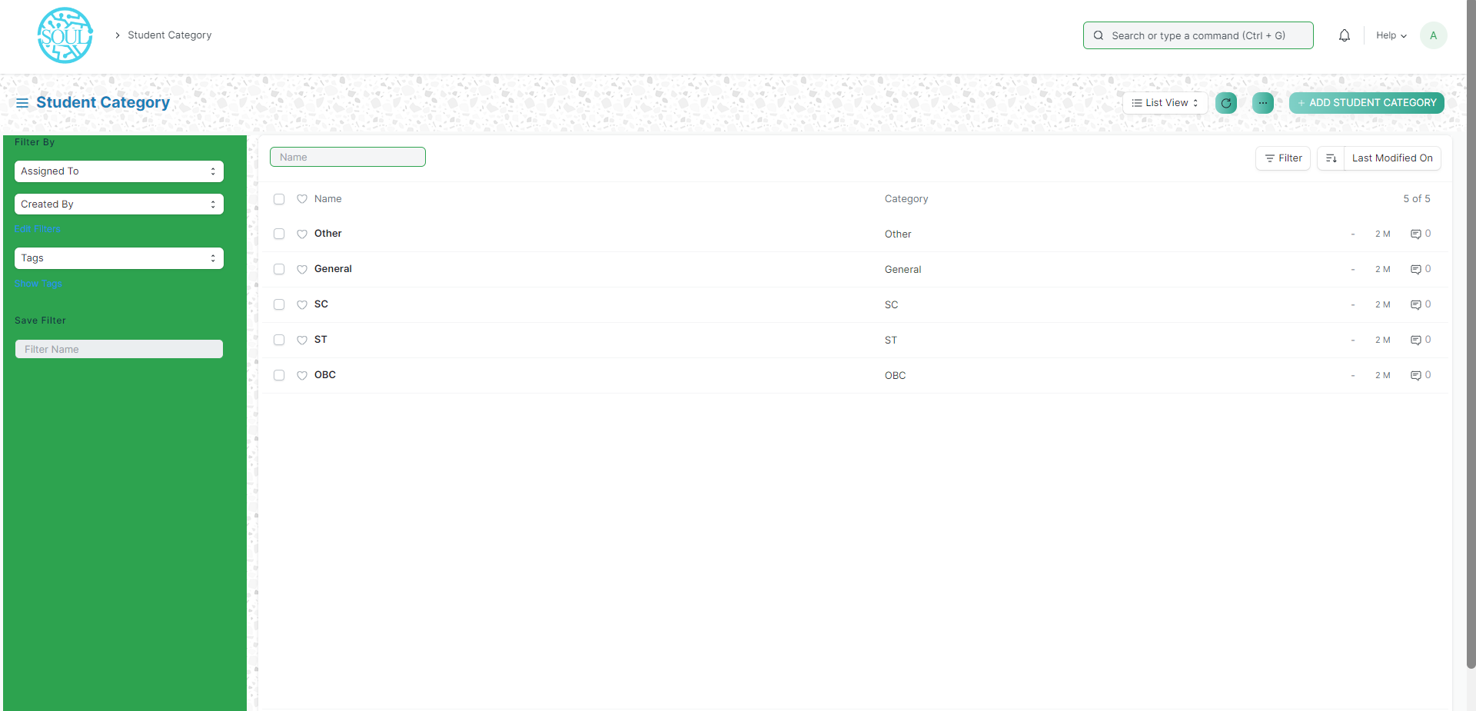

How to create a Student Category?

To create a new student category, click on New Student Category and add the name of the Student Category.

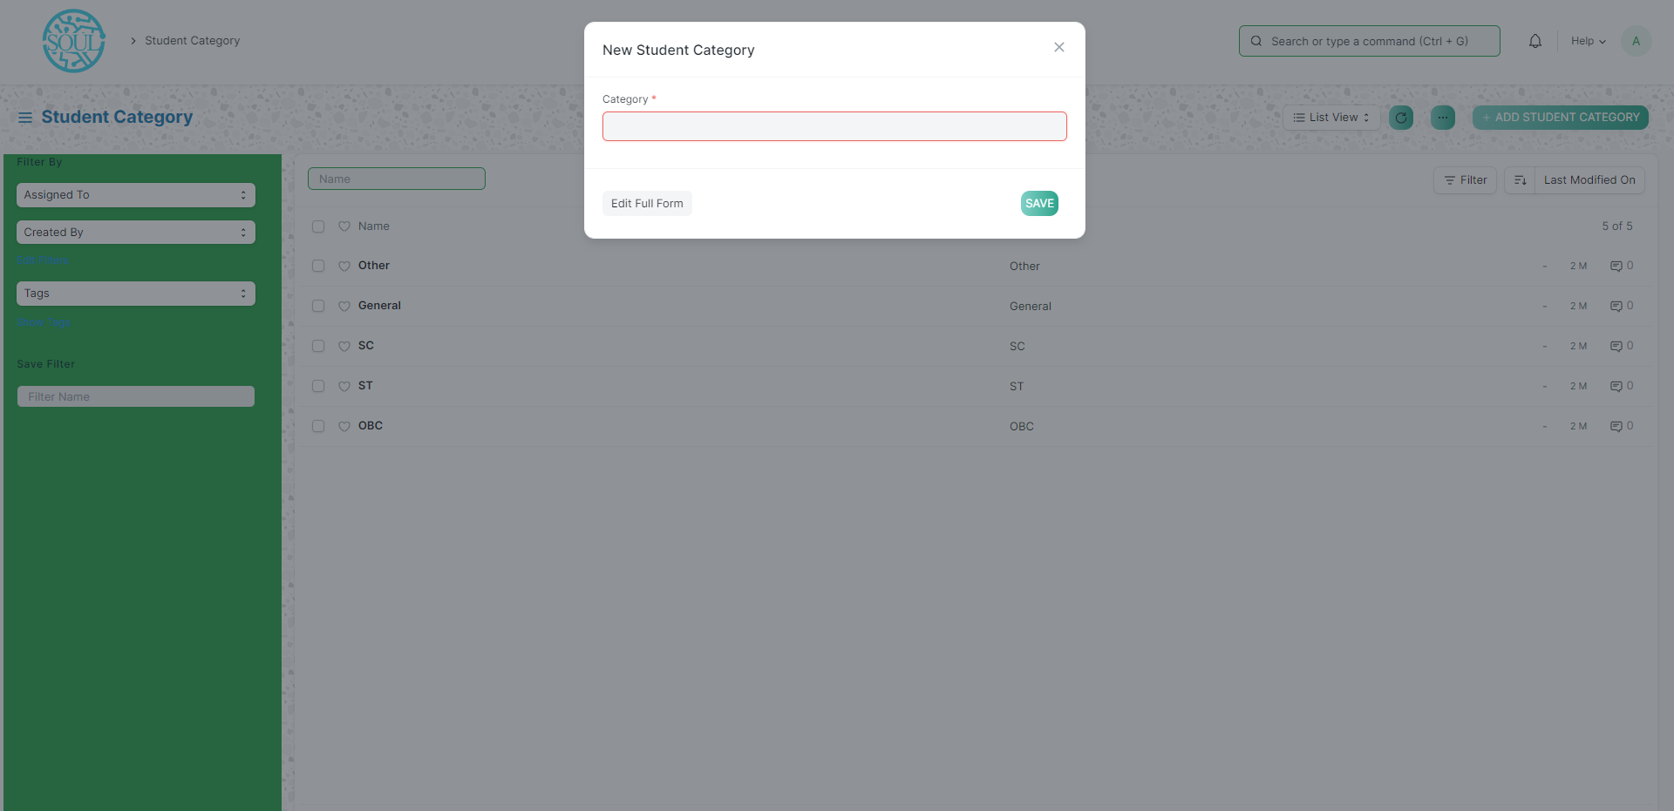

**Student Batch Name**

A Student batch is a group of students studying the same Program together.

To access the Student Batch Name, go to:

Home > Polytechnic > Student Details > Student Batch Name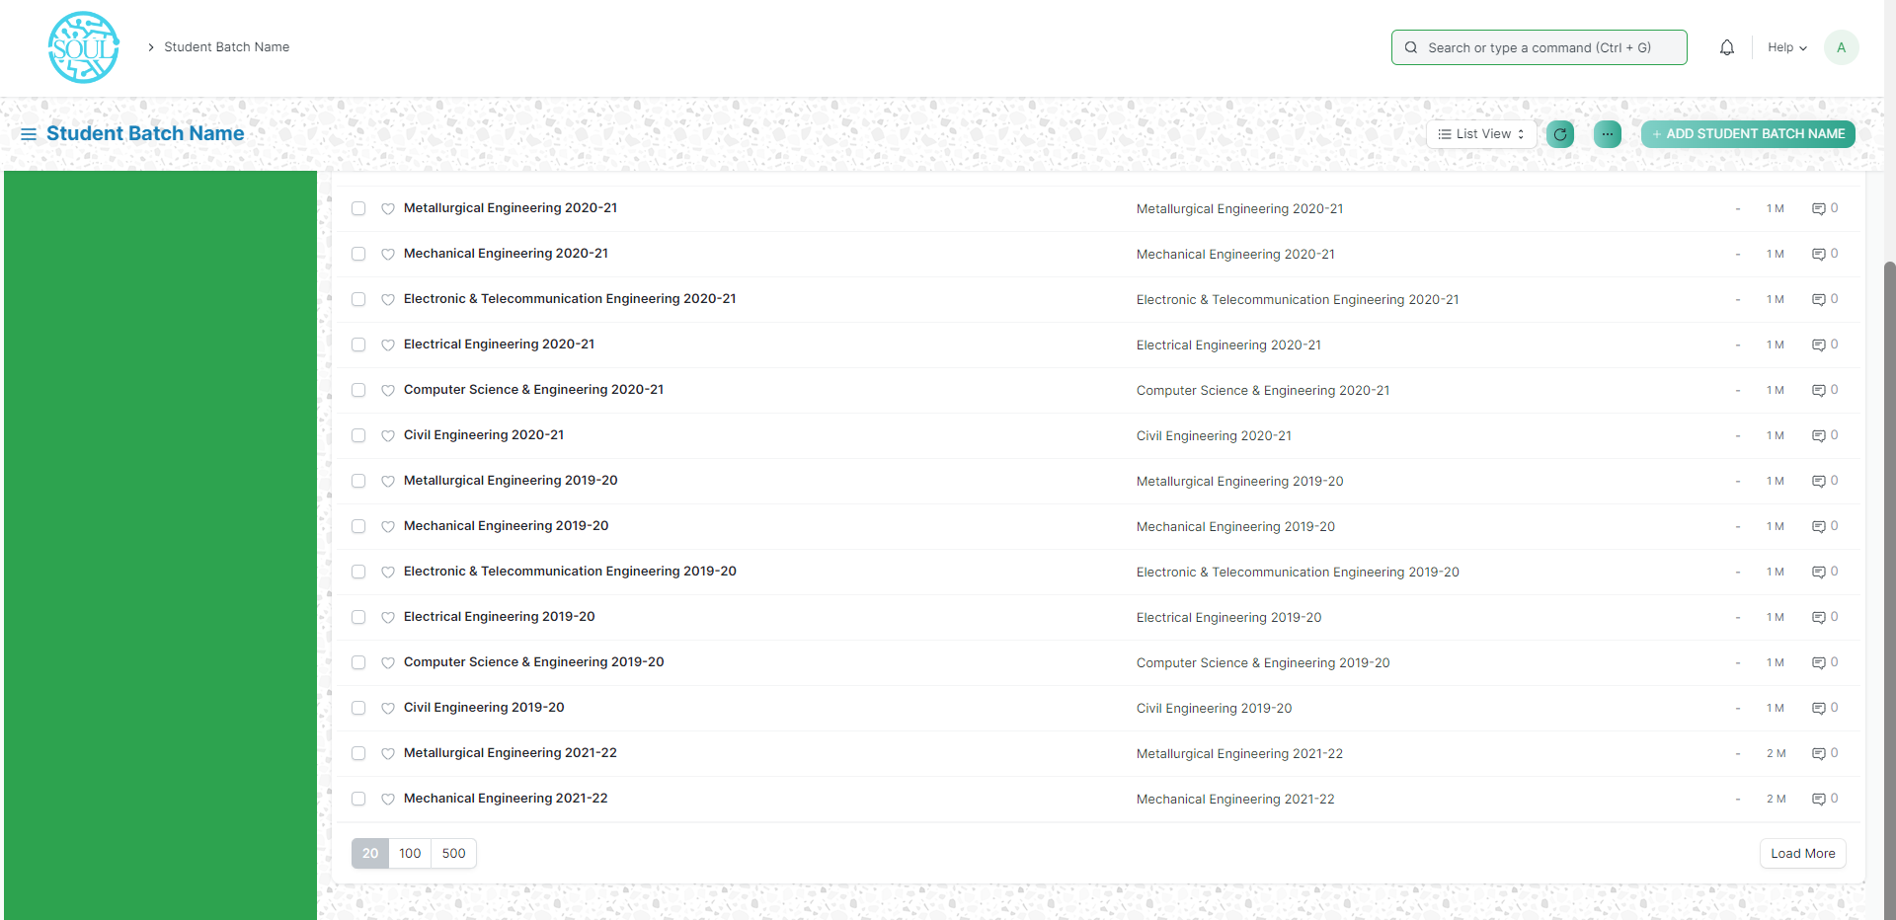

How to create a Student Batch Name?

To create a new student Batch Name, click on New Student Batch name and add the name of the Student Batch.

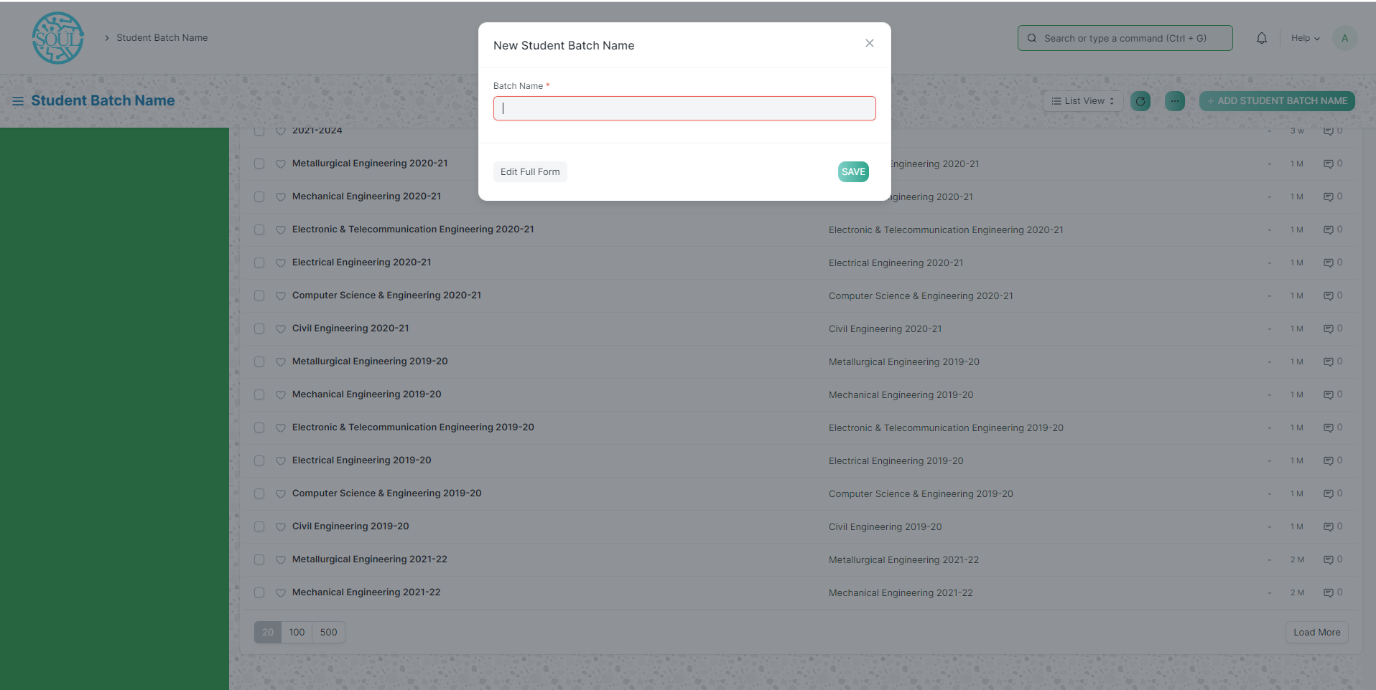**Admission Master Module**

**Academic Events**

An Academic Events are individual events which are used for creating an Academic Calendar while preparing a Schedule for a Class.

To access Academic Events, go to:

Home > Polytechnic > Admission Masters > Academic Events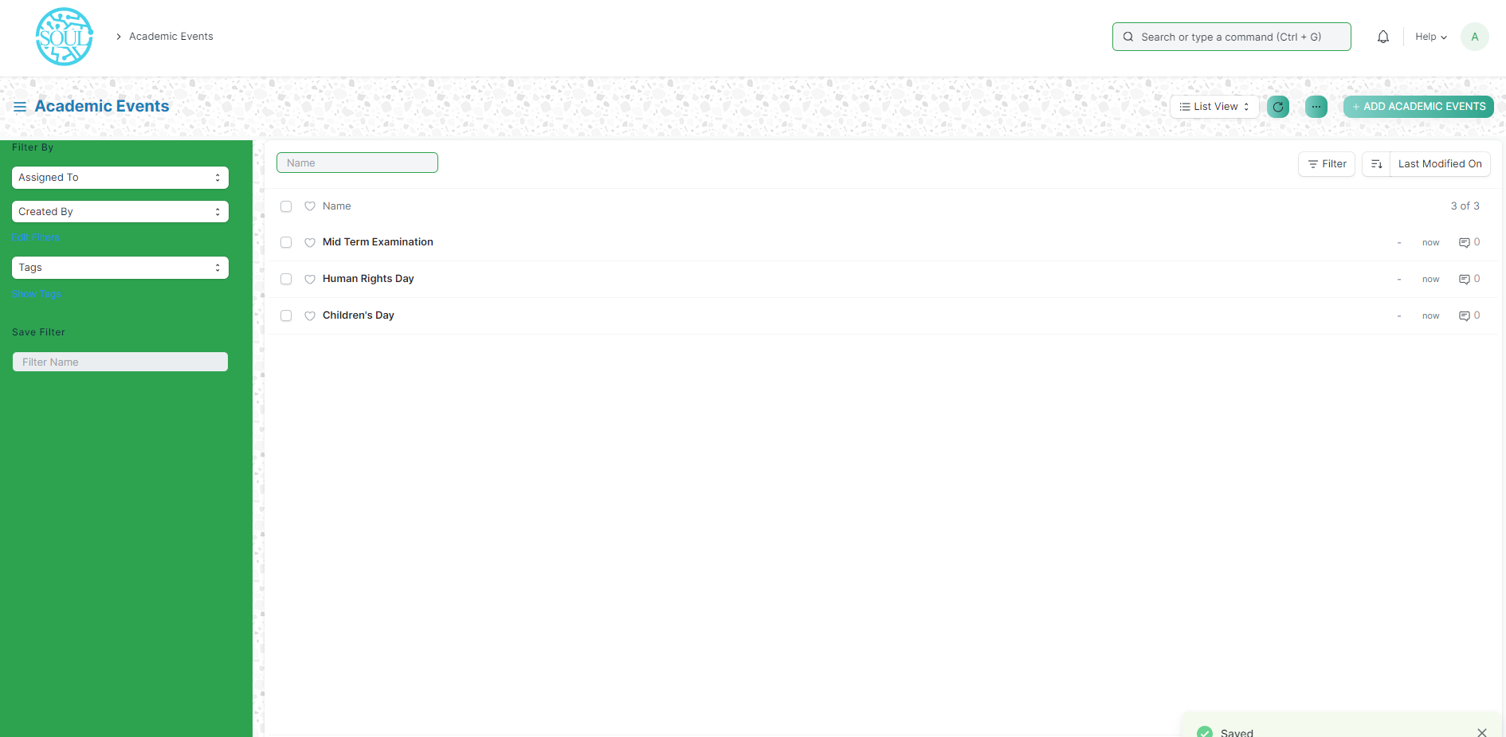

How to create an Academic Event?

1. Click on Add Academic Events.
2. Add Event Name.
3. Save.

**Academic Calendar Template**

Academic Calendar Template is a list of all different events that will be happening in an Academic year for a particular class.

To access Academic Calendar Template, go to:

Home > Polytechnic > Admission Masters > Academic Calendar Template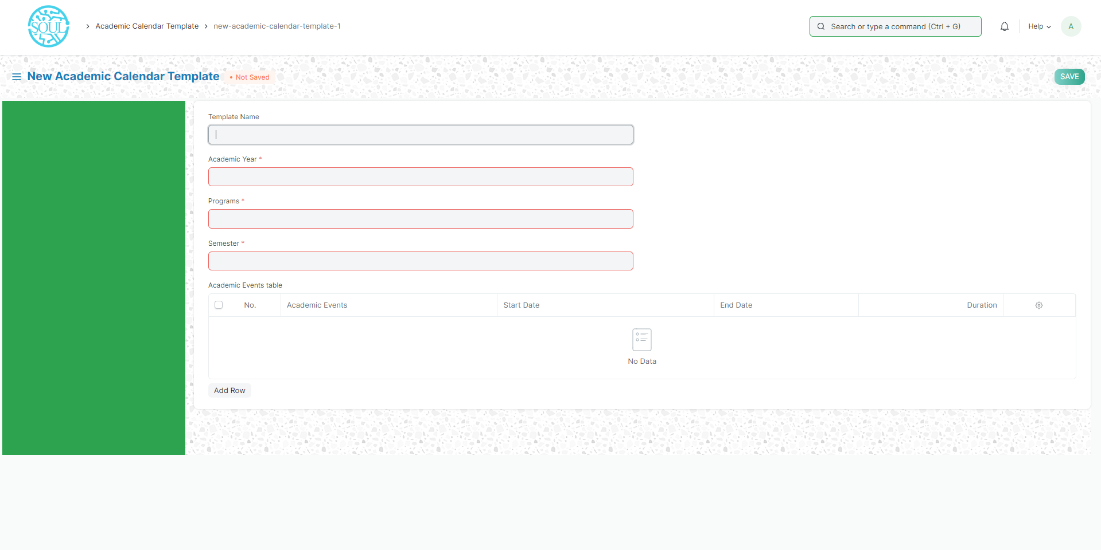

How to create an Academic Calendar Template?

* 1. Click on Add Academic Calendar Template.
  2. Add Template Name.
  3. Select Academic Year and Class from the List that appears on clicking on those fields.
  4. Select Academic Events and add Starting date, End date for the events.
  5. Save.

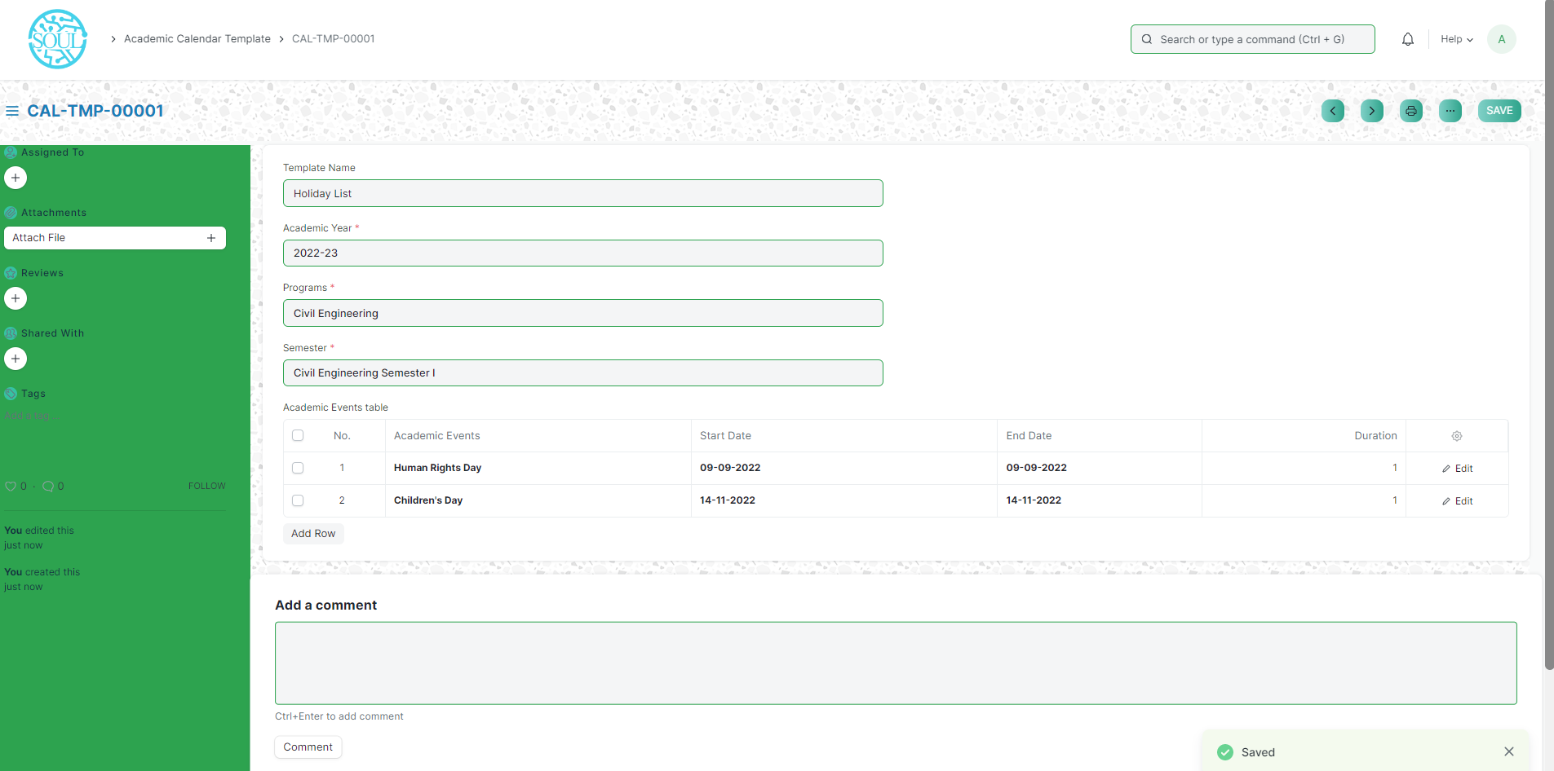

**Academic Calendar**

Academic calendar is a schedule of all of the events that occur in an academic year. These events may include examination dates, spring break or reading week and the last day of the semester. It can also be useful for prospective students. Each educational institution creates its own academic calendar with their own defined dates.

To access Academic Calendar, go to:

Home > Polytechnic > Admission Masters > Academic Calendar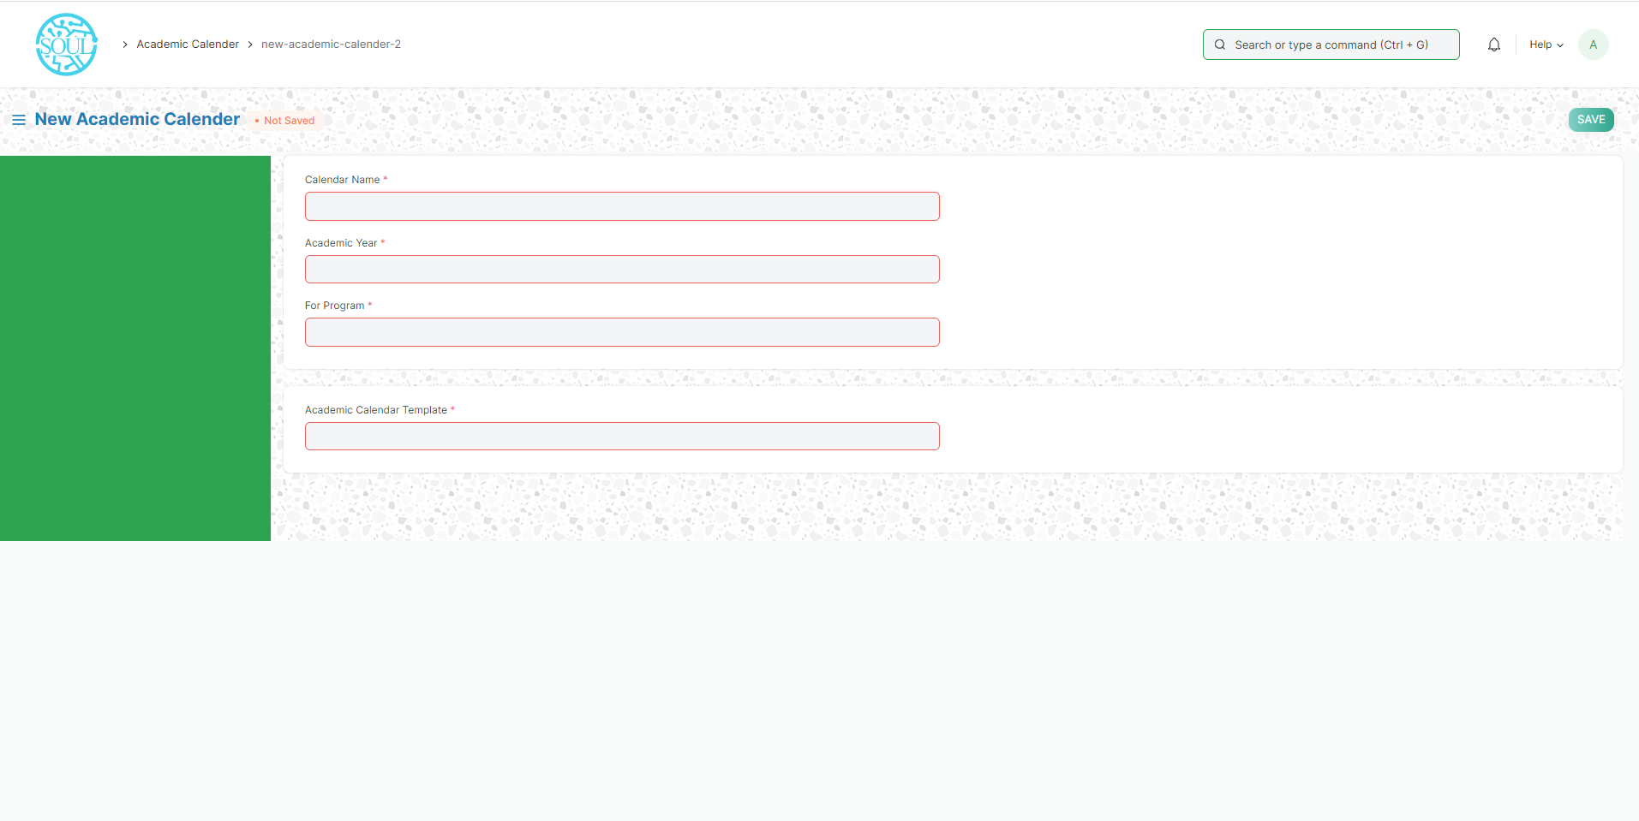

How to create an Academic Calendar?

Click on Add Academic Calendar Template.

Select and enter Calendar Name.

Select and enter Academic Year.

Select and enter “For Program”.

Select and enter “Academic Calendar Template”.

The details mentioned in the Academic Calendar Template are auto-fetched.

Save and Submit.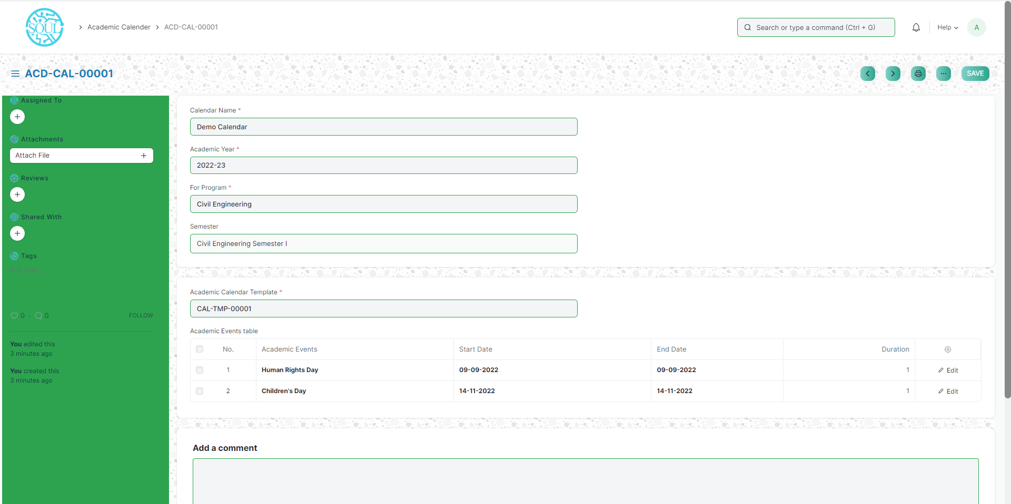

**Application and Enrollment Module**

**Program Enrollment**

Program Enrollment is the record of enrollment of a student in a given program and chosen courses for a particular Academic Term.

To ensure that students are associated with a particular program in the system, their Program Enrollment must be created. The mandatory course in that program is automatically filled in the Enrolled Courses table while the elective or optional courses can be selected manually.

To access Program Enrollment, go to:

Home > Polytechnic > Application & Enrollment > Program Enrollment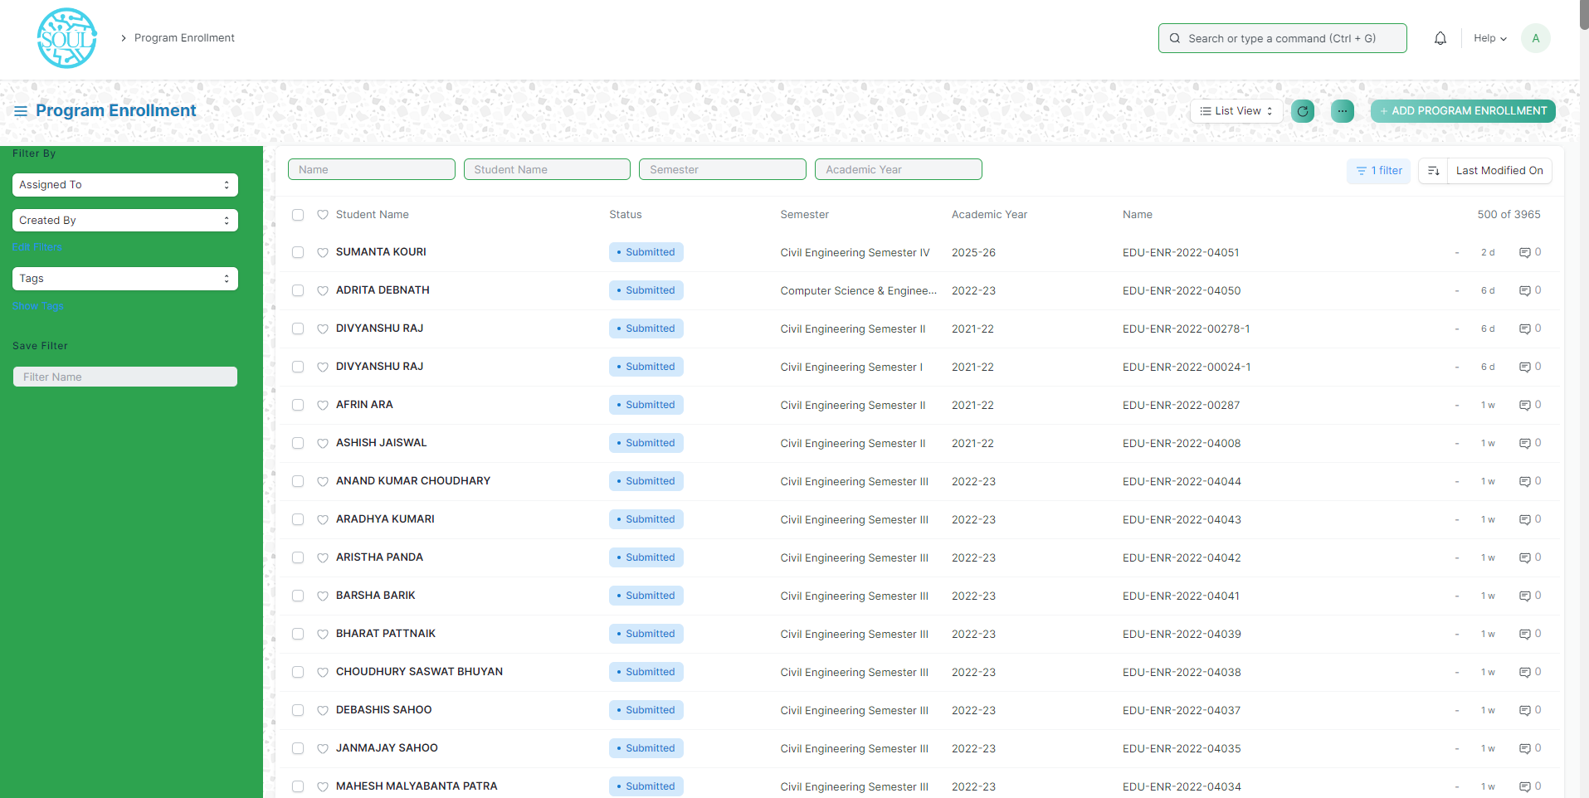

How to create a Program Enrollment?

1. Go to the Program Enrollment List and click on Add Program Enrollment.
2. Select the Student whom you are getting enrolled in the program.
3. Select the Program under which you are getting the student enrolled.
4. Enter the Academic Year for which the student is getting enrolled.
5. The Enrollment Date for the form would by default be set on the current date, the same, however, can be changed if needed.
6. Save and Submit.

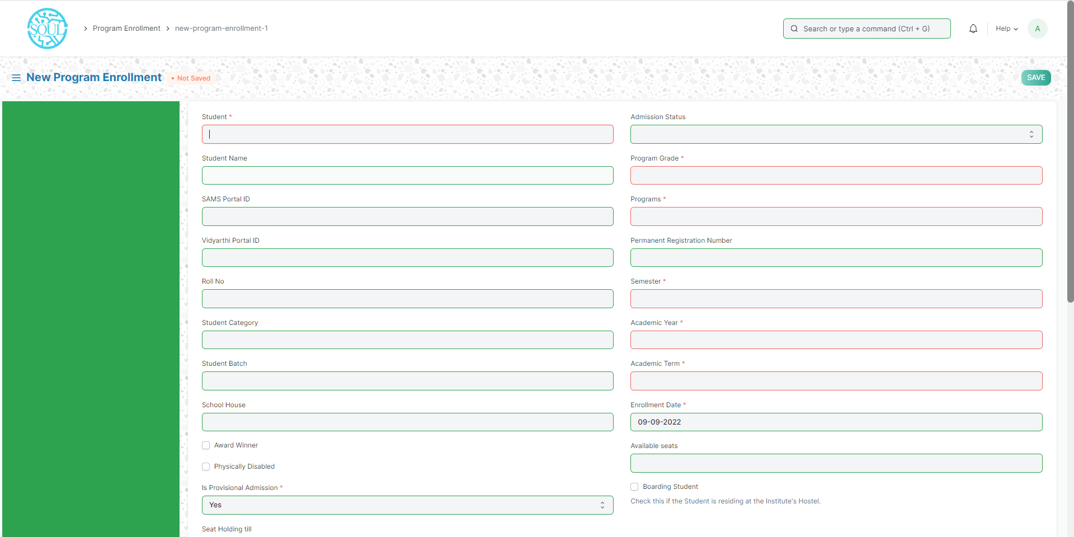

Additional Options while creating a Program Enrollment

1. Student Category: Select the category if the student belongs to a particular student category.
2. Academic Term: Select the Academic Term.
3. Student Batch: Select the batch if the student belongs to a particular student batch.
4. Student House: Select the House if the student belongs to a particular student house.
5. Boarding Student: Check this if the Student is residing at the Institute hostel. In this case, the fee structure would accordingly be updated.

**Course Enrolment**

Course Enrollment is the record of enrollment of a student in a given program and chosen courses for a particular Academic Term.

To ensure that students are associated with a particular program in the system, their Course Enrollment must be created/auto-generated. The mandatory course in that program is automatically filled in the Enrolled Courses table while the elective or optional courses can be selected manually.

If the student has applied online for the admission in a particular Program and the application is approved, then the Course Enrollment is auto-created from within the Program Enrollment record.

To access Course Enrollment, go to:

Home > Polytechnic > Application & Enrollment > Course Enrollment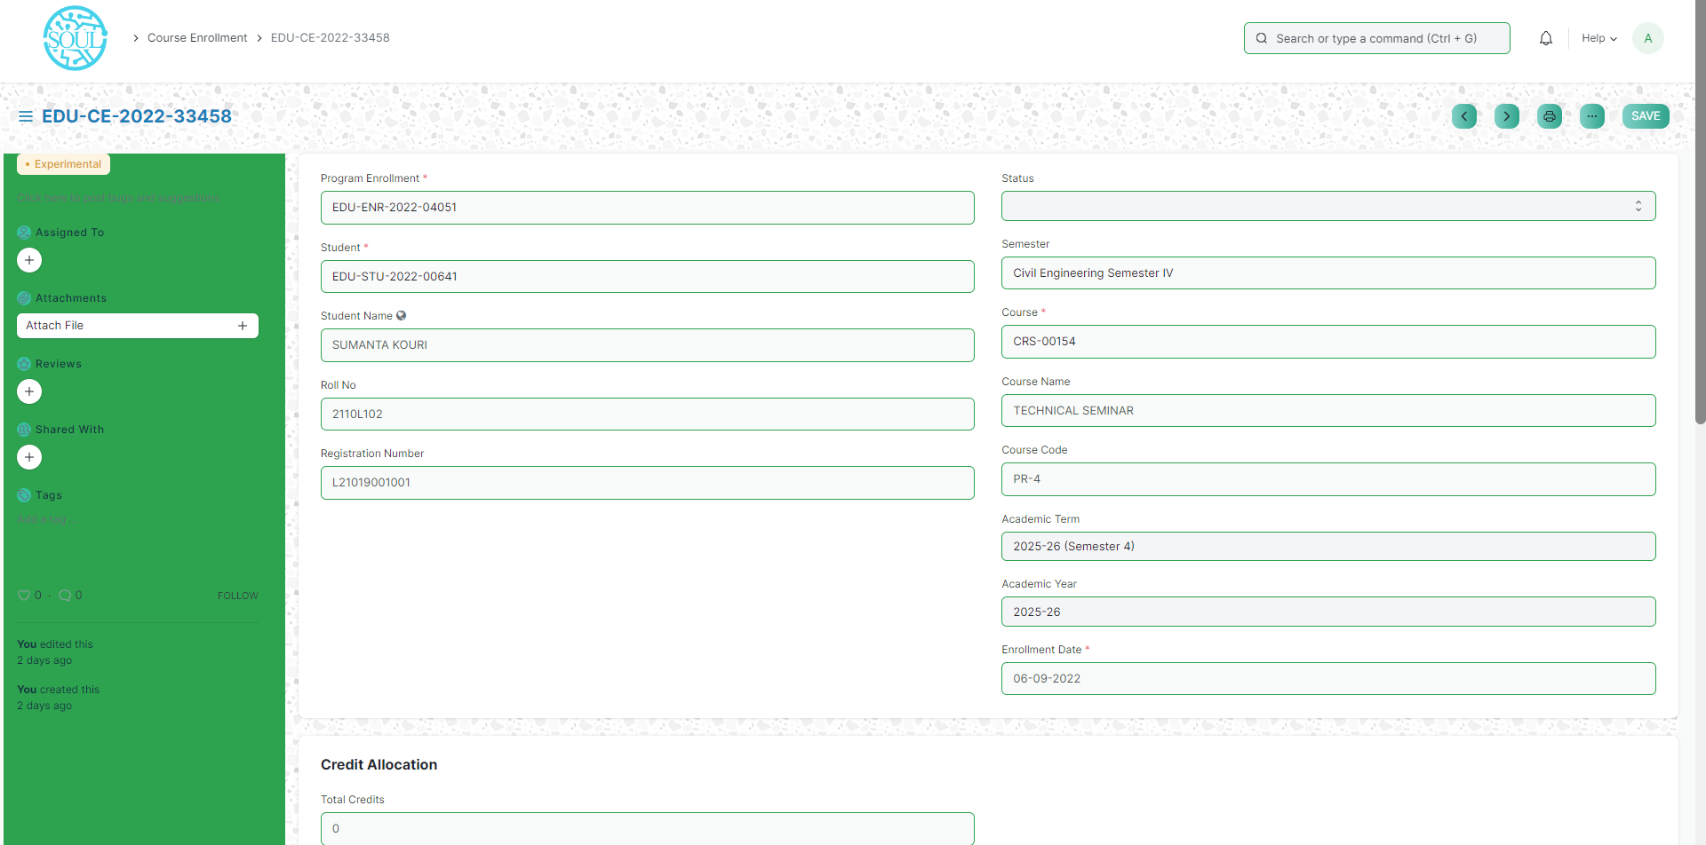

**Student Reregistration Tool**

Students Reregistration tool is a tool for Reregistering the students once they have completed the examination and there is a need to promote the entire group of students to the next semester.

To access Fee Schedule, go to:

Home > Polytechnic > Application & Enrollment > Student Reregistration Tool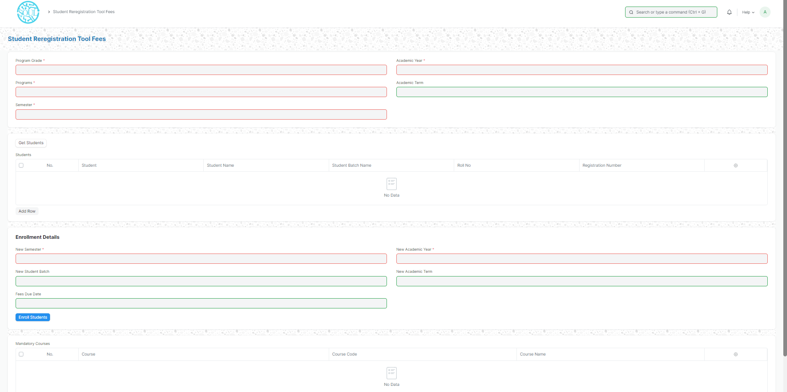

How to use the Student Reregistration Tool?

1. Open Student Reregistration Tool.
2. Select Program Grade, Programs, Semester, Academic Year, Academic Term.
3. Click on the Get Student button and all the students for that program will be fetched in the table.
4. Select Additional Course if required.
5. Select and enter New Semester, New Student Batch, New Academic Year, New Academic Term.
6. The mandatory courses for the next semester will be auto fetched.
7. Click on the “Enroll Students” button.

Branch Change Module

Branch Change Declaration

There is generally a method where you can change your branch from one to another branch.

To access Branch Change Declaration, go to:

Home > Admission > Branch Change > Branch Change Declaration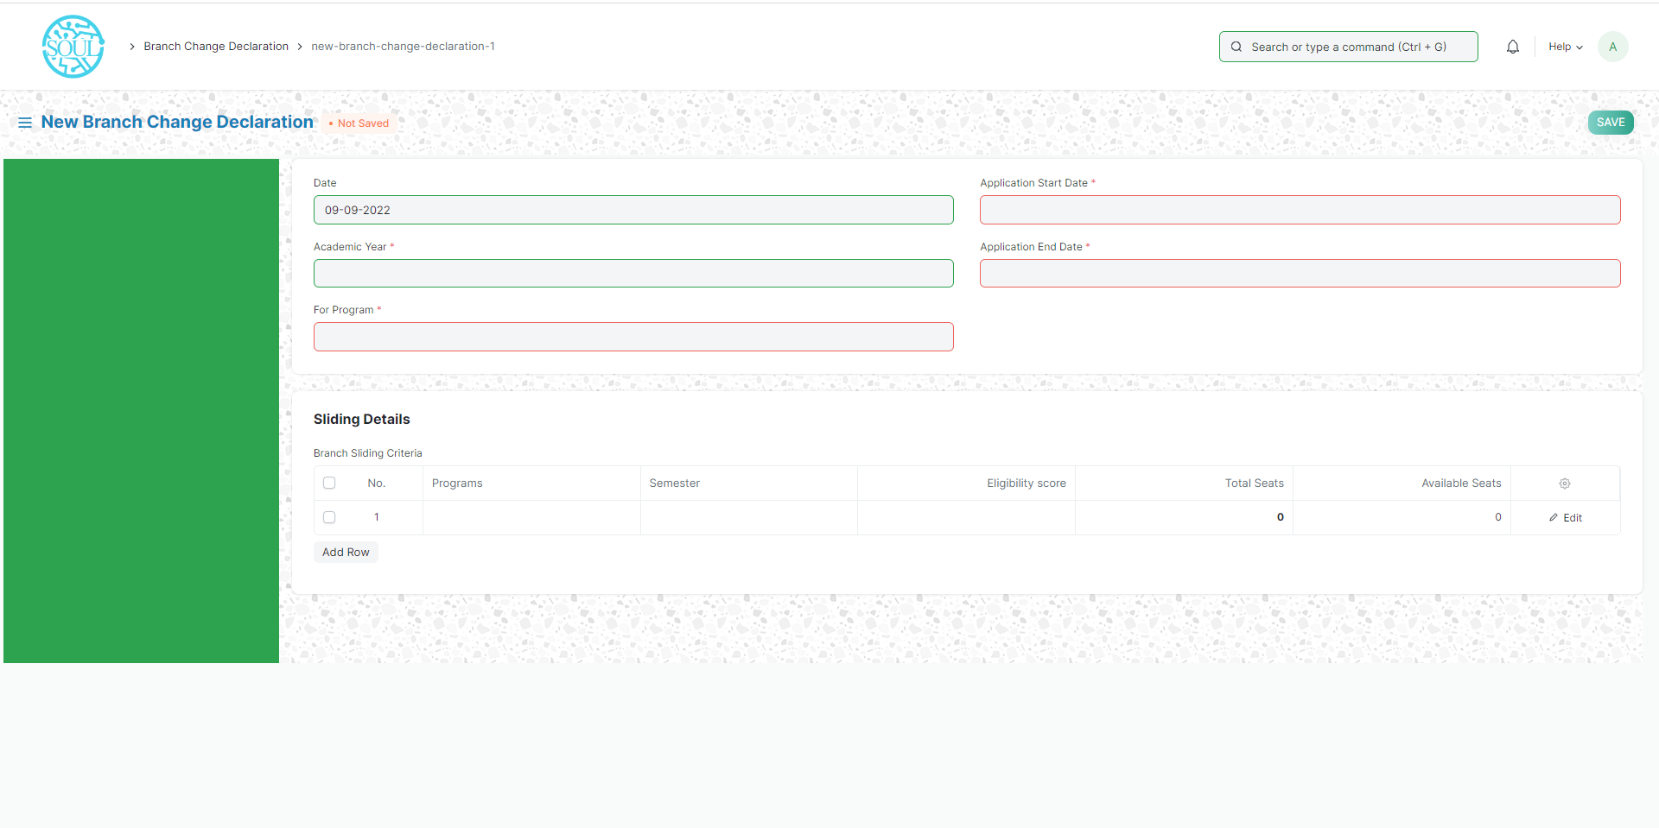

How to create Branch Change Declaration?

1. Go to Branch Change Declaration, click on Add Branch Change Declaration.
2. Select and enter “For Program”.
3. Select and enter Application Start Date and Application End Date.
4. Select and enter in the Sliding Details table.
5. Select and enter Program Name in Branch Sliding Criteria for which Branch Change is declared.
6. Select and enter the Semester.
7. Select and enter Eligibility score.
8. Click on the Edit option.
9. Select Update Seats option in the new pop-up screen.
10. Select Add or Deduct Balance in “Type”.
11. Select and enter no of seats.
12. Save and Submit.

**Branch Change Application**

At the end of the first year, CGPA is the most important criterion for the eligibility of the branch change. Moreover, since the number of students entering into a certain department is limited the competition is tough which requires a greater amount of effort from the students who are desperate for a branch change.

To access Branch Change Application, go to:

Home > Polytechnic > Branch Change > Branch Change Application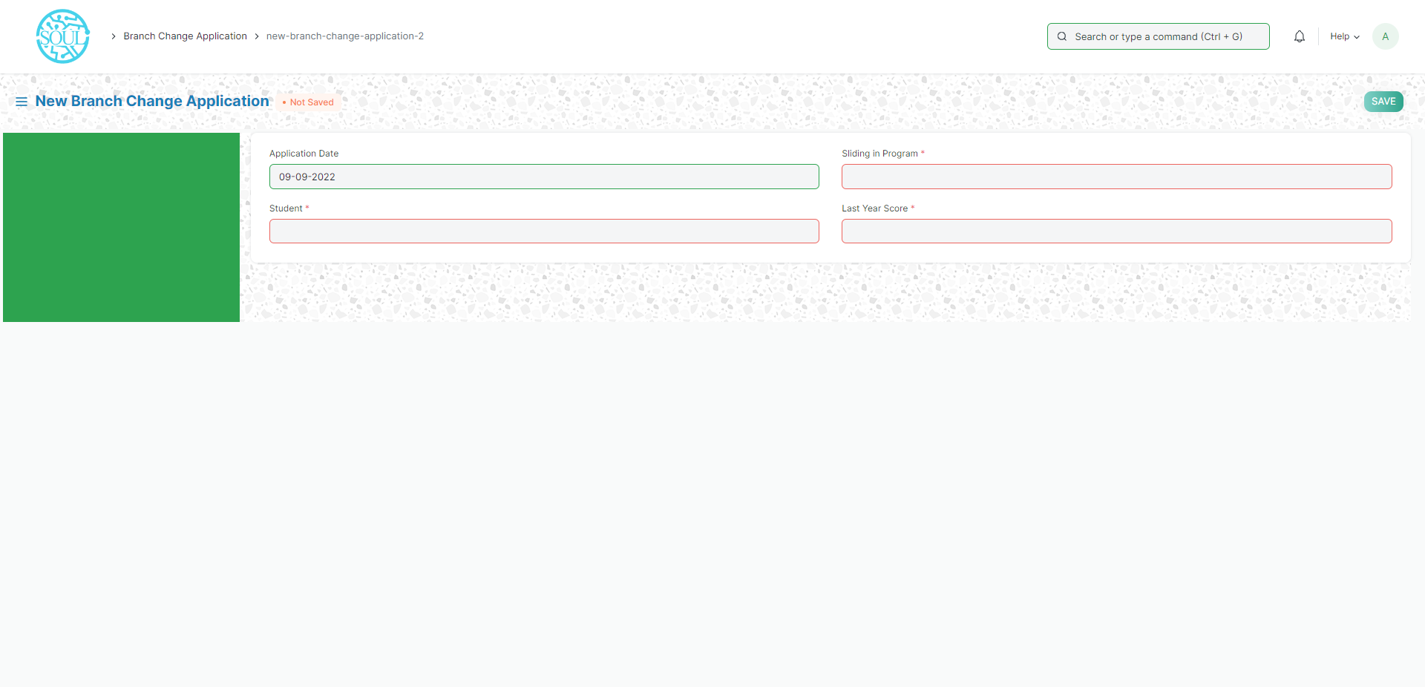

How to create a Branch Change Application?

* + - 1. Go to Branch Change Application, click on Add Branch Change Application.
      2. Select and enter Student Name.
      3. Select “Sliding in” and choose the option from the dropdown menu.
      4. Select and enter Last Year Score.
      5. Save and Submit.

**Examination Module**

Exam Type

The Exam Type allows you to create and set values for a particular Exam Declaration which shall be beneficial to determine the type of examinations that are being conducted and can be evaluated on the basis of it.

For example, An Exam Declaration can be classified as Mid Term Examination or End Term Examination.

To access Exam Type list, go to:

Home > Polytechnic > Examination > Exam Type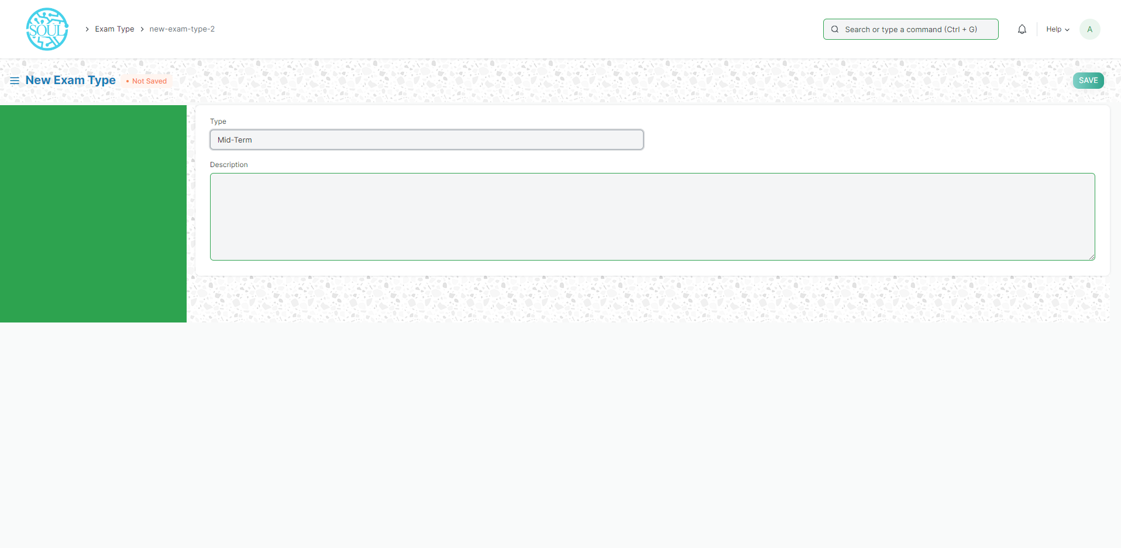

Exam Declaration

The Exam Declaration will allow you to declare an exam for various programs.

To access the Exam Declaration Process, go to:

Home > Polytechnic > Examination > Exam Declaration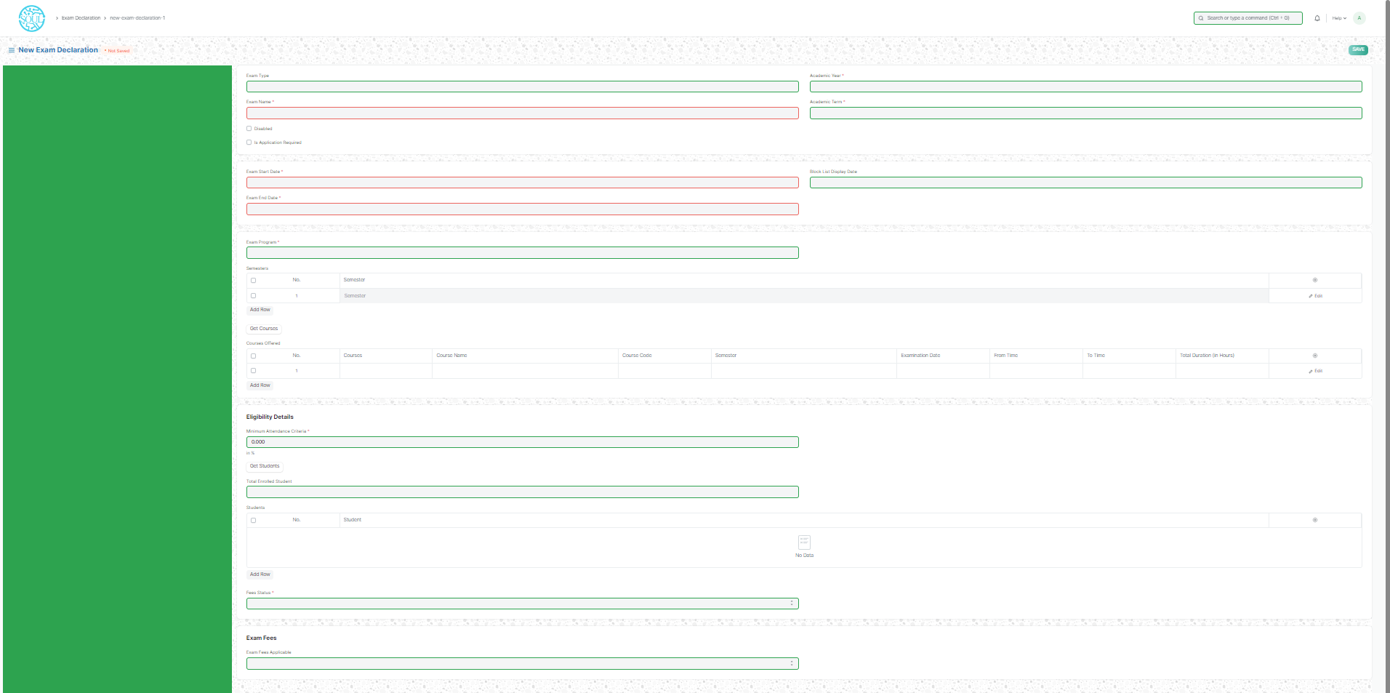

How to create an Exam Declaration?

1. Add Exam Declaration: Enter the Exam Type, Exam Name, Academic Year, Academic Term.
2. Select and add the Exam Start Date.
3. Select and add the Exam End Date.
4. Select and add the Block List Display Date.
5. Select and add the Admit Card Issue Date.
6. Select and add the Exam Program.
7. Semesters related to the selected Exam Program will be displayed on the drop-down list.
8. Select Get Courses.
9. Courses Offered Table:
   1. Courses from the semesters selected are auto populated in the table.
   2. Select and the Examination Date
   3. Change the “From Time” and “To Time” to your desirable schedule.
   4. Total duration (in Hours) will be auto generated.
10. Select and enter the eligibility details:
    1. Select and add Minimum Attendance Criteria
    2. Select the Fee Status from the list of drop-down options
11. Select and add Exam Fees if applicable-If Yes, then select and add various fee structures along with due date in the fee structure table according to Student Category.

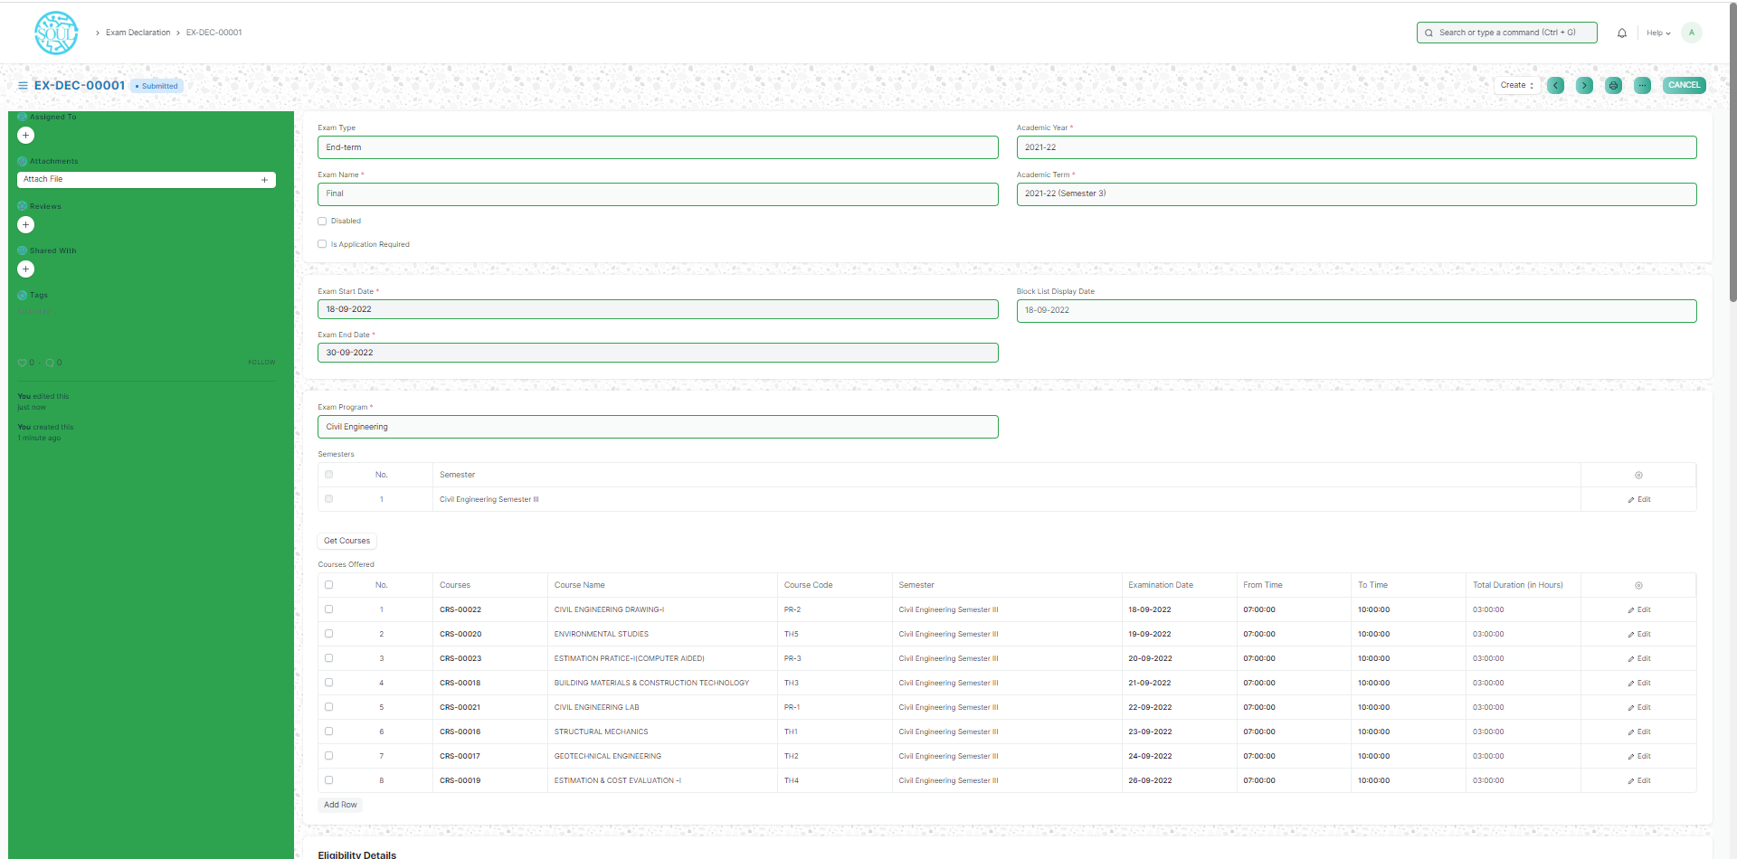

**Fee Structure-**

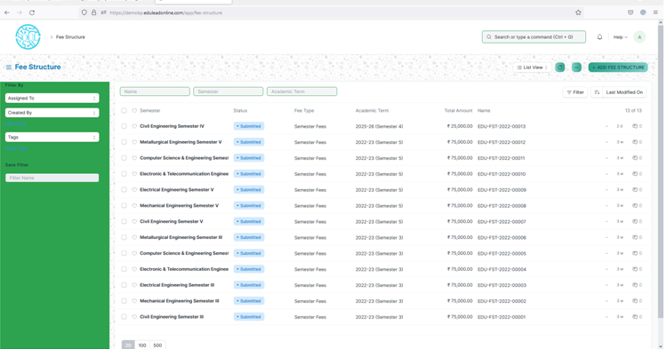

Click on Add Fee Structure to create the Fee Structure. Fill the mandatory fields (Marked as red *).

Fill the fields like Programs, Semester, Fee Type*, Academic Year* and Academic Term.

In Components section fill the data like Fees Category, Income Account and Receivable Account. Then click on save button. The form will be in Draft mode. If user wants to update anything then he/she can change the required field value and again save it. Then click on Submit button to submit the fee structure for that particular program.

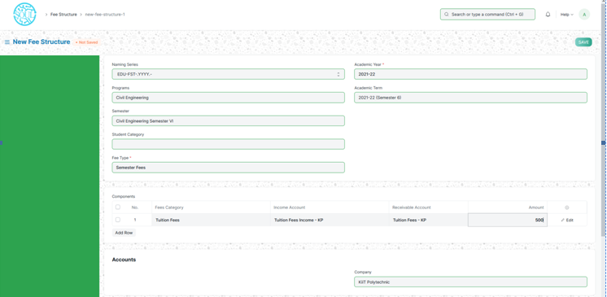

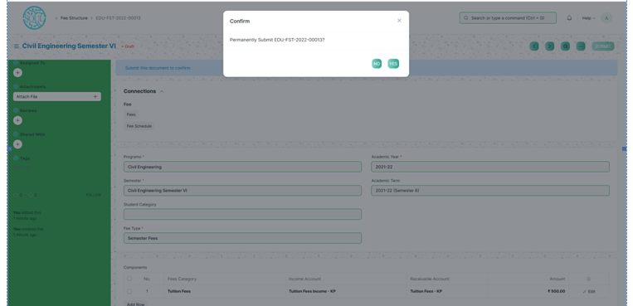

Then the page will be shown as below.

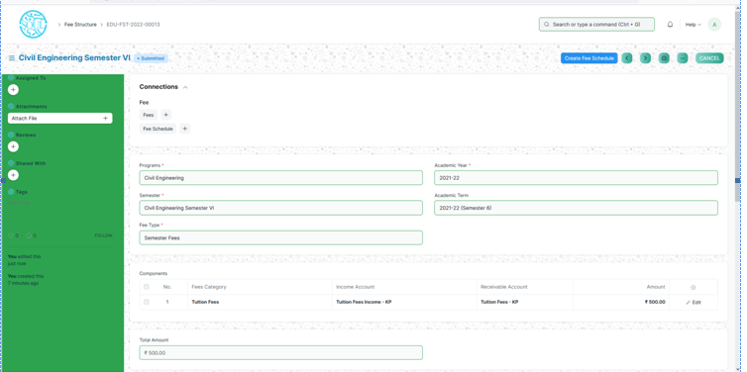

Fee Schedule-

On load of the page there will be a button Add Fee Schedule. Click on that the below screen will be shown.

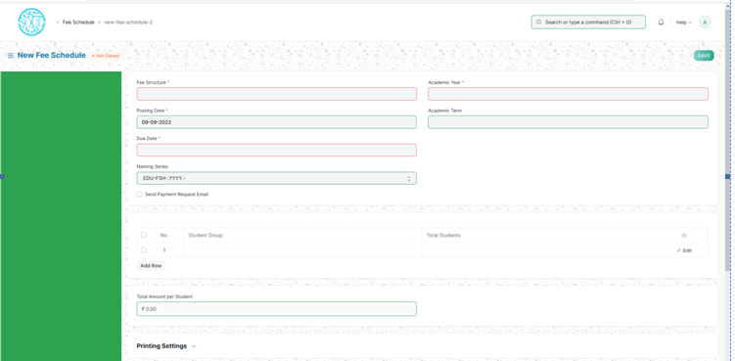

Fill all the mandatory fields and other required fields to create a fee schedule.

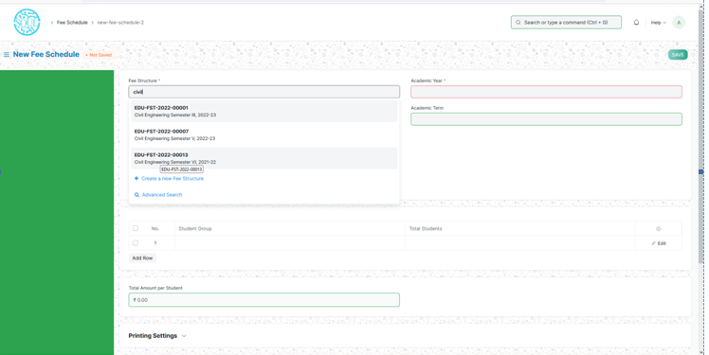

Fee structure:

Enter the fee structure on which the fee schedule will be generated. Once entered the Fee structure, the data will be auto filled related to that particular Fee structure. Then other mandatory and other fields need to be filled up.

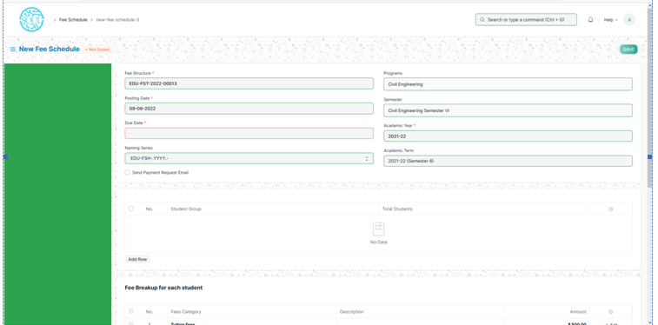

Fee can be scheduled for group of student. So for this enter the Student Group and no. of students will be auto fetched. Then click on Save and Submit button to save the form.

Fee Category- To add fee category. Add name and save the form.

Fees- Below is the Fees screen.

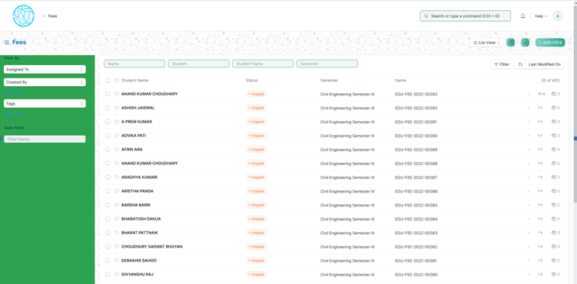

To add new Fees click on Add Fees. Then below screen will be loaded.

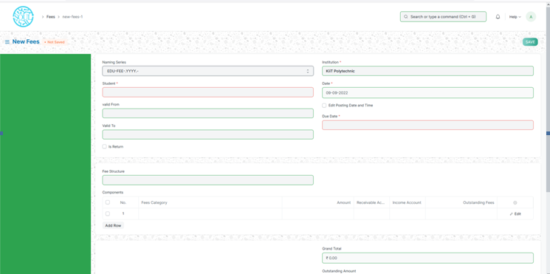

Fill the form with required and mandatory data.

Student: is the mandatory field. Once select a student the form will be auto filled with student related data.

In the Component section add the Fees Category, Amount, Receivable account and Income account.

Then click on Save and Submit to submit it.

Fee Waiver-

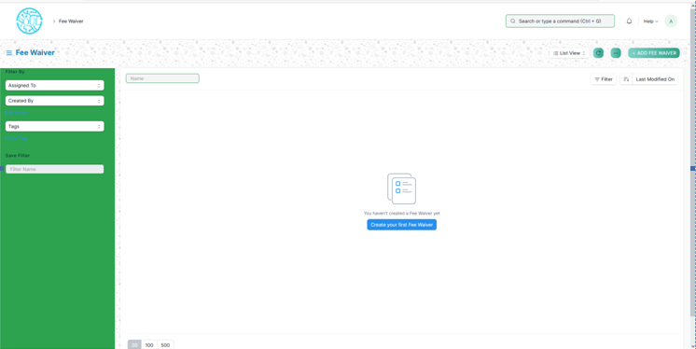

Click on Add Fee Waiver to add fee waiver category.

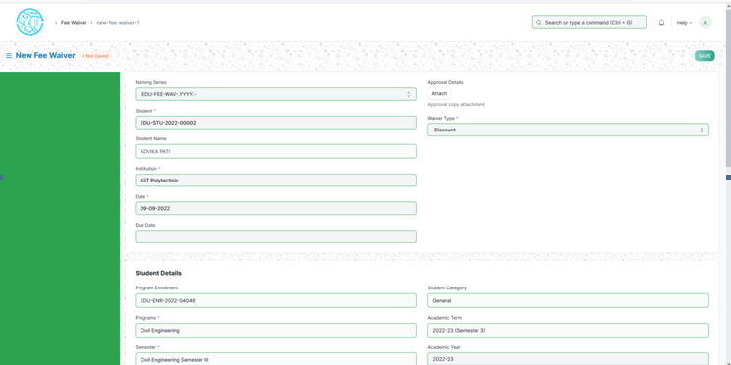

Select a student for whom the fee waiver will be applicable and the type of waiver. Fill the mandatory fields in the form and click on save and submit to submit the form.

Payment Entry-

Landing screen for the Payment entry.

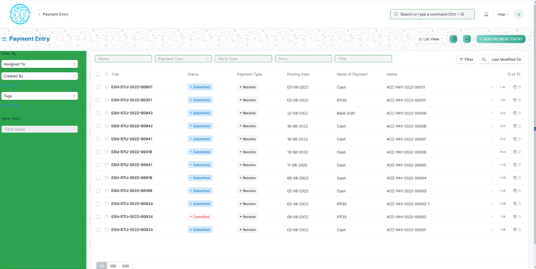

To add new payment entry click on Add Payment entry button.

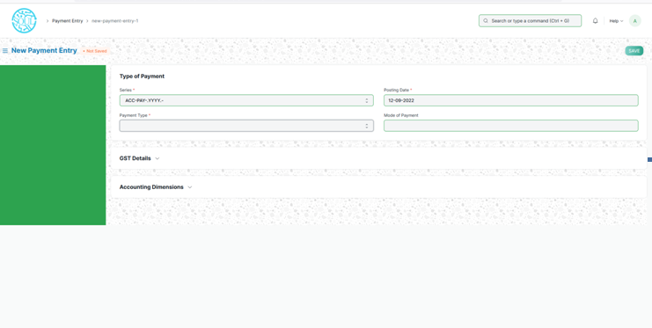

Select the Payment Type Receive. Where the institute will get the amount.

Select Party Type. Here user has to select Student from whom the amount will be deducted. Then all the student details will be auto populated.

Then in the Accounts section filled the mandatory fields. In the Account Paid to select the account. Entered the Paid Amount to be paid. Click on Get Outstanding Fees, it will fetch all the fees belongs to the particular student.

In the Transaction ID section, enter the cheque No. and the Reference Date. Then click on Save and submit the form.

Surplus Payment Entry-

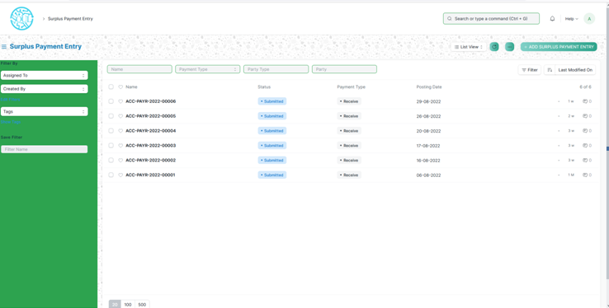

Click on Add Surplus Payment Entry button it will load the below screen.

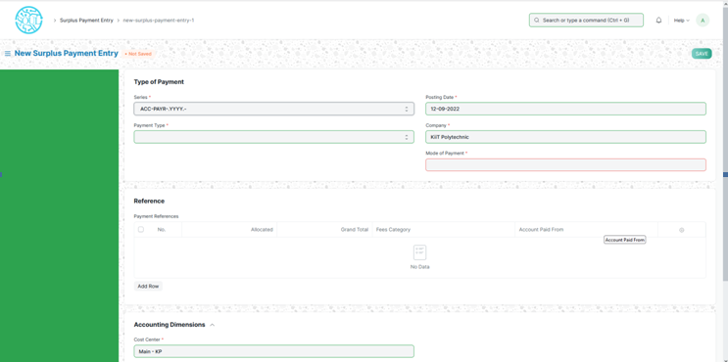

Fill all the mandatory fields. Payment Type, Mode of Payment, Party Type and Party. Once user select the party it will auto fetched all the data of that particular party.

In the Reference section, fill the mandatory fields like allocated (amount field), Fees category and account paid from. Then click on save and submit the form.

Bank Reconciliation Statement –

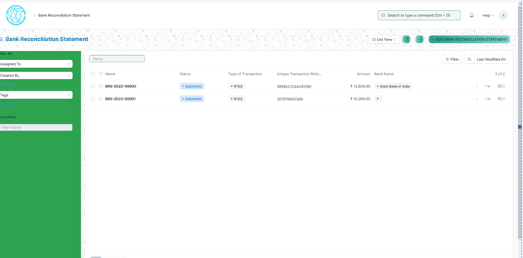

To add new bank reconciliation statement click on the button then it will load the below screen.

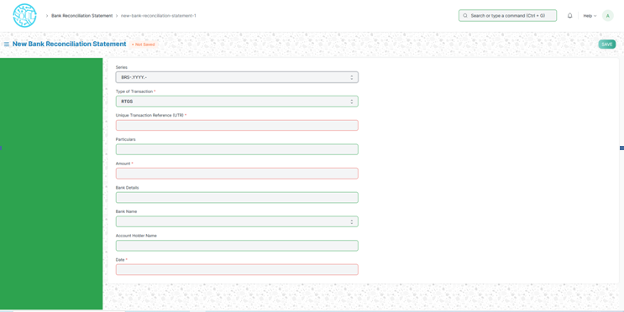

Here fill the mandatory fields. Then click on save and submit button.

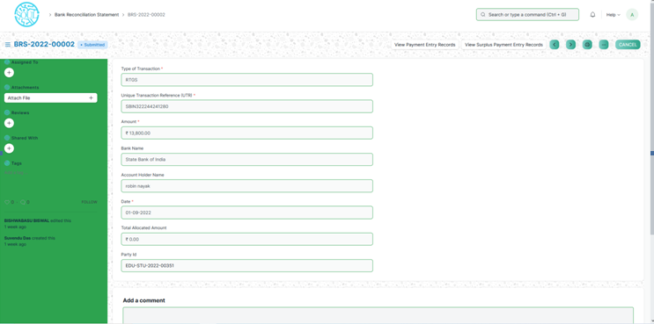

Payment Details Upload-

In this form student has to enter the data that will be used during bank reconciliation time. Fill all the mandatory fields, then click on Save and submit button.

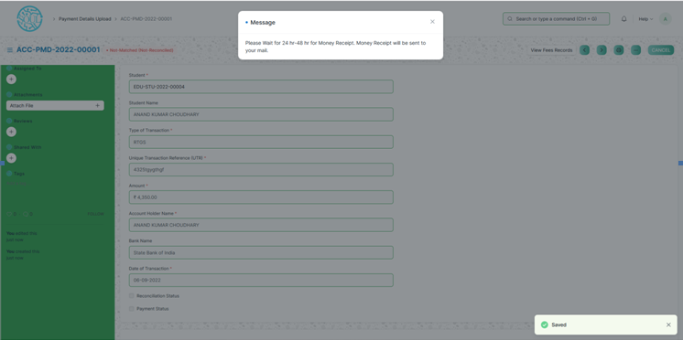

The system will prompt a pop up message.

Auto reconciliation –

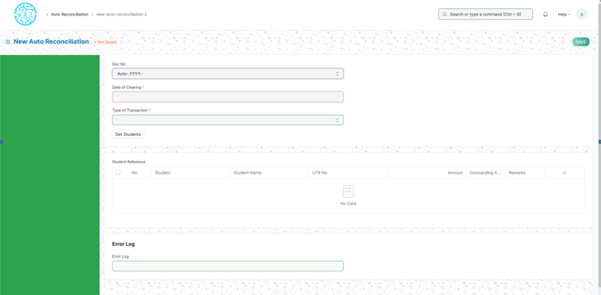

For auto reconciliation user needs to enter date of clearing and type of transaction. Then click on Get Students, it will fetch all the list of students those satisfy the filter. Then click on save and submit.

Reports:

GL Report-

It shows the general ledger report.

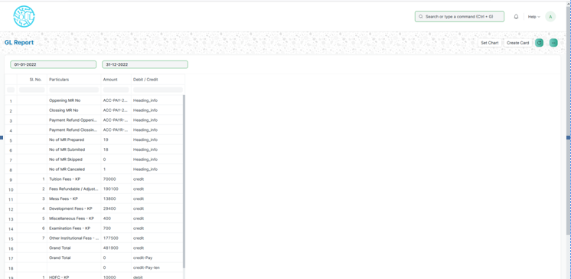

Select the date and then from 3dots click on Print button. It will show as a report format.

Student Status Report-

It will show the details of fees about individual student. Here Party is the mandatory field.Enter the party then it will show the details.

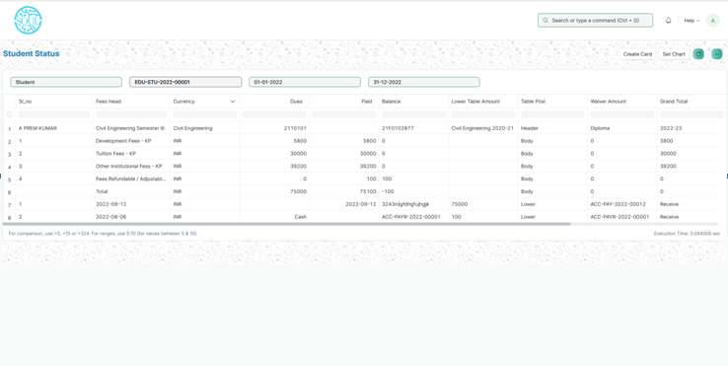

Program Fees Report-This report will show the fees on program wise.

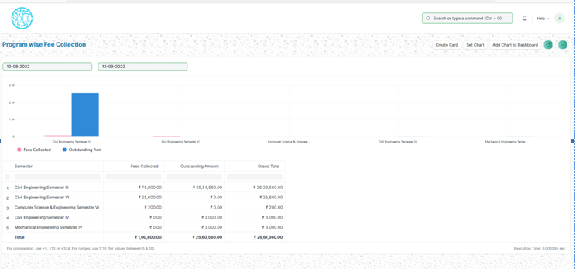

Student Fees collection report-

This report will show the details like amount paid, outstanding amount of all the students.

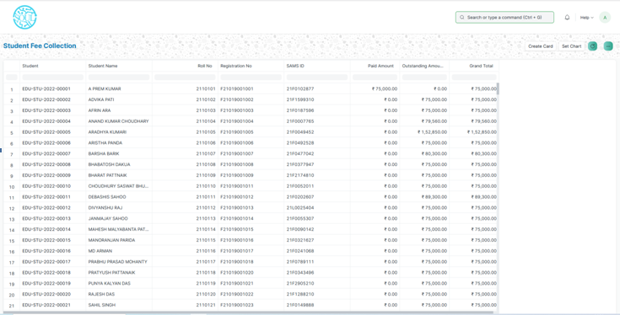

Student wise Outstanding Dues-

This report will show the outstanding due on student basis .User needs to enter Programs, Academic term (mandatory fields)

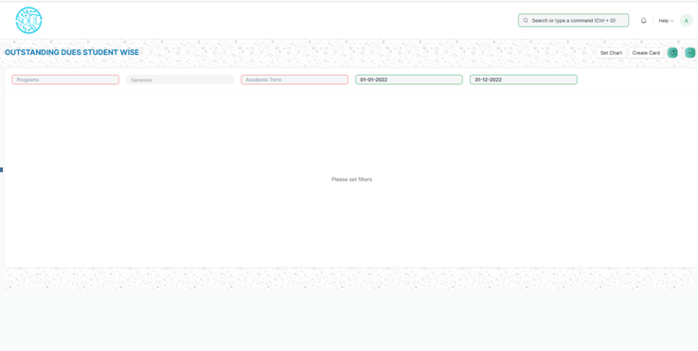

Employee wise Collection-

This report will show the total fees collection on basis of employee. User needs to enter the Employee id in the search box and select the date range.

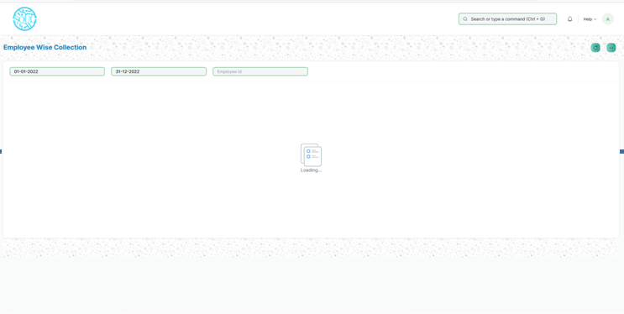

Batch wise outstanding dues-

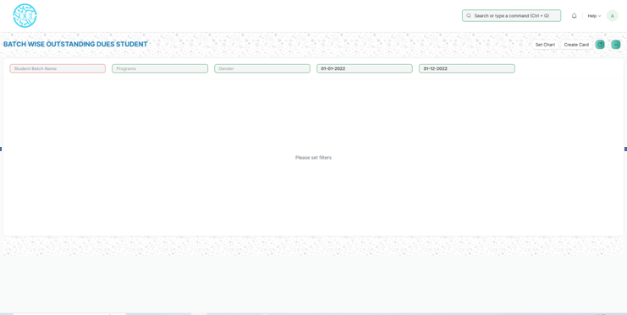

In this report user has to enter the student batch to see the detail report. To add more filter option user can put filter on Programs.

**Miscellaneous Module**

**Transport Service**

The Transport Service allows you to assign students for Bus facilities.

To access the Transport Service Process, go to:

Home > Polytechnic > Miscellaneous > Transport Service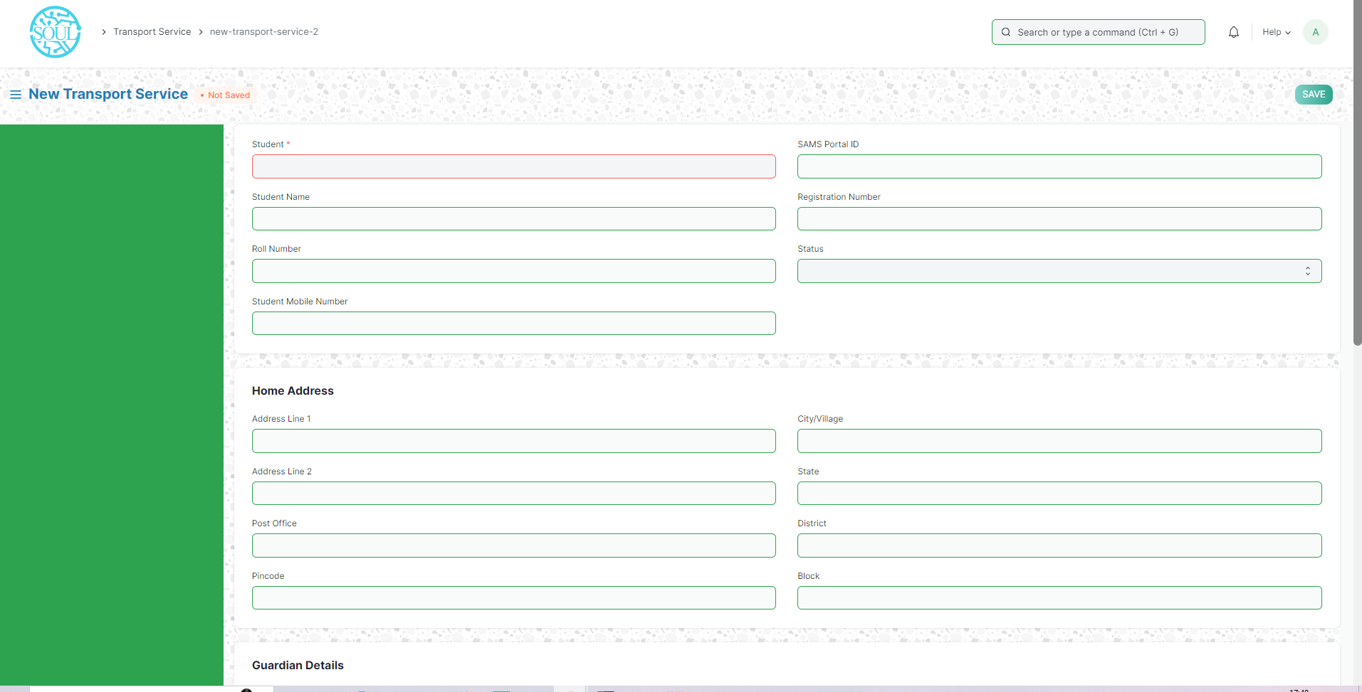

How to create a Transport Service?

1. Go to Transport Service, click on Add Transport Service.
2. Select Student
3. Add Emergency Contact Number and Location(Bus Pickup Point)
4. Click On Save
5. Select Status as Approved or Rejected.
6. If You Select Approved then you select “Yes” or “No” for Fees in Fees Applicable field.
7. If you select “Yes” then two fields fetch one for Amount and another for Due Date then add amount and due date.
8. Click on Save and Submit.

**Fees Due Tool**

In the fees due tool you send notification(email) to those students whose fees are due. You can also send it to the guardians.

To access the Fees Due Tool Process, go to:

Home > Polytechnic > Miscellaneous > Fees Due Tool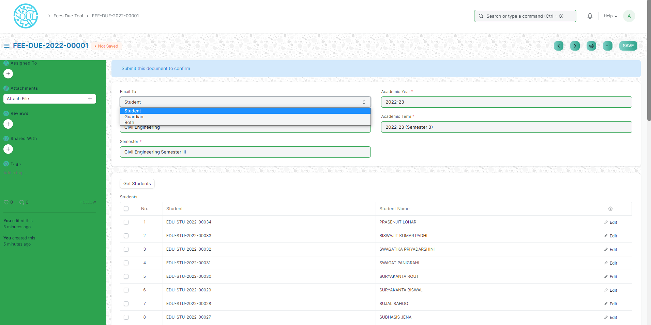

How to create a Fees Due Tool?

1. Go to Fees due Tool, click on Add Fees Due Tool.
2. Select “Email To” as Student, Guardians or Both for sending email.
3. Add Program, Semester, Academic Year and Academic Term.
4. Click on Get Students button where all Students fetch who enroll in that program that you mention.
5. Click on Save and Submit.
6. After Submit one button fetch top right of the corner(bulk email) through that button you are able to send email when you want.
7. When you click on the “bulk email” button then one pop-up comes on that pop-up you write content and send it.

